Nuno Miguel Pinto Lopes Dinis Santos

**Full product to motivate exercise**

apps+game

**Dissertação no âmbito do Mestrado em Engenharia Eletrotécnica e de Computadores orientada pelo Professor Paulo Jorge Carvalho Menezes e apresentada ao Departamento de Engenharia Eletrotécnica e de Computadores da Faculdade de Ciências e Tecnologia da Universidade de Coimbra**

Julho de 2025

Page intentionally left blank.

**Acknowledgements**

I would like to express my gratitude to my teacher, Professor Paulo Menezes, for presenting me with this challenge. A special thank you to my colleague, Tiago Santos, for ensuring I adhered to good programming practices and for contributing valuable ideas. To my girlfriend, whose unwavering support, insightful feedback, and assistance made all the difference throughout the year. To my stepdad, Leandro Sousa, and my mother, Isabel Lopes, for never doubting me, always giving me the strength to move forward, and offering ideas that helped shape this project.

This achievement is as much yours as it is mine.

**Resumo**

Vários estudos já mostraram que um estilo de vida sedentário é comum em pessoas de todo o tipo de idades. É sabido que contribui significativamente para problemas de saúde tanto no presente, como no futuro da vida de uma pessoa.

Apesar de muitos estudos já terem sido feitos e alguns protótipos criados, nenhum foi complexo o suficiente para ser transformado num produto.

Este trabalho foi criado para solucionar este problema, indo mais longe do que um simples protótipo. Neste trabalho, tiramos vantagens de novas tecnologias disponíveis e um sistema de recompensa em vida real para criar um produto completo, designado para promover a actividade física em jovens adultos. Este ecossistema consiste num jogo desenvolvido em Unity, uma API, um website para registo de utilizadores, uma aplicação de superutilizador e um programa python.

A API serve como parte central, controlando as comunicações entre as componentes para assegurar a integridade da data. O jogo foi desenvolvido para encorajar o exercício físico ao incorporar mecânicas que recompensam o movimento e exercício, tornando este mais atractivo para os utilizadores. Para estes puderem usar movimentos para controlarem o jogo, um programa proxy foi criado que captura a posição do esqueleto do jogador e usa as coordenadas das articulações para criar movimentos e mapeá-los para o Unity. O frontend permite aos utilizadores registarem-se para poder jogar o jogo e cada um ter o seu progresso. Finalmente, uma aplicação de superutilizador que permite controlar o progresso dos utilizadores e permitir que estes possam colecionar as recompensas.

Este ecossistema tecnológico procura oferecer uma solução efectiva e atractiva para combater o sedentarismo, encorajando estilos de vida mais saudáveis entre jovens adultos.

**Abstract**

Several studies already shown that sedentary lifestyle is common in people of all ages. It is known that contributes significantly to health concerns in the present and future of a person’s life.

Although many studies have been conducted and some prototypes created, none were complex or finished enough to be regarded as a product.

This work was created to address this issue by going a step further of just a simple prototype. In this work, we take advantage of new available technology and a real-world base reward system to create a complete product designed to promote physical activity among young individuals through innovative digital solutions. This ecosystem consists of a game developed in Unity, an API, a website to handle registration, a superuser application (SU app), and a Python-based proxy program.

The API serves as the central hub, managing communication between components and ensuring data integrity. The game is designed to encourage physical activity by incorporating mechanics that reward movement and exercise, making workouts more engaging for young users. For users to be able to use physical movements to control the game, a proxy program was created which captures the user skeleton position and uses their joint coordinates to build movements and map them to Unity. The frontend allows the users to registrate so they can play the game, and each have their own progress. Finally, a superuser application enables monitoring and management, ensuring that the users can collect their rewards.

This technological ecosystem aims to offer an effective and engaging solution to combat sedentarism, encouraging healthier lifestyles among young people.

**Contents**

1 14

Manual 14

1.1. Motivation 15

1.2. Problem Statement 15

1.3. Objectives and contributions 15

1.4. Document structure 15

1.5. Game 16

1.6. Proxy program 16

1.7. Frontend website misteriosaquaticos.pt 16

1.8. Backend API 16

1.9. Super user APP 17

1.10. Tech choices 17

1.10.1. Unity 17

1.10.2. Blazor 17

1.10.3. MAUI 17

2 18

Game development 18

2.1. Considerations to have in game development 19

2.2. Mistérios Aquáticos Overview 19

2.3. Design choices 20

2.4. Optimization techniques 20

2.4.1. Unity Profiler 20

2.4.2. Combining static meshes 24

2.4.3. Baking lights 24

2.4.4. Object pooling 24

2.4.5. Vertex shaders 24

2.4.6. Fog 24

2.4.7. Render distance 25

2.4.8. Limited Drawing 25

2.5. Shaders 26

2.6. Player engagement 29

2.6.1. Sounds 30

2.6.2. Particles 30

2.6.3. Ambient 30

2.6.4. Tutorial 31

2.6.5. Zones 33

2.6.6. Achievements 41

2.6.7. Unlockables 41

2.7. Player retainability 43

2.7.1. Day streak 43

2.7.2. Meaning progression 43

2.7.3. Game credits 43

2.8. Scalability 43

2.8.1. Creating new zones 44

2.8.2. Creating new fish spawn volumes 46

2.8.3. Adding new fish species 48

2.9. Fish movement 49

2.10. Adjusting values 49

2.11. Unity scripts 51

2.12. Gameplay 53

3 54

Proxy program 54

3.1. Socket communication 55

3.2. OpenCV and MediaPipe 56

3.3. Calibration 57

3.4. Mapping movements in Proxy program 59

3.5. Fail safes 62

3.6. Receiving data in Unity from Proxy 63

4 66

Frontend development 66

4.1. Web page 67

4.2. Port configuration 68

4.3. Validations 68

4.4. API connection 69

5 70

Backend API development 70

5.1. SOLID principles 71

5.2. Architecture & good practices 71

5.3. REST APIs 71

5.4. Testing the API 71

5.5. Validations 72

5.6. Endpoints 72

5.7. Swagger 74

5.8. Postman 74

5.9. Port configuration for API 75

5.10. Client Resilience 75

5.11. Authentication 76

5.12. Database connection 76

5.13. Github 76

5.14. Database 77

5.14.1. Why SQLite? 77

5.14.2. Tables schema 77

6 78

Deployment 78

6.1. Server 79

6.2. Command line 79

6.3. WinSCP 79

6.4. Portainer 79

6.5. Domain misteriosaquaticos.pt 80

6.5.1. Mapping server IP to domain 81

6.5.2. Why use a domain? 81

6.6. Docker 81

6.6.1. Why use Docker? 81

6.6.2. Setup in server 81

6.6.3. Docker images 81

6.6.4. Docker container 82

6.7. Faster deployment 82

6.7.1. GitActions 83

6.7.2. Docker hub 83

6.7.3. Watchtower 84

6.8. Nginx SSL certificate 84

6.8.1. Why need SSL certificate? 84

6.8.2. Adding the SSL certificate 85

7 86

Super user APP 86

7.1. MAUI app context 87

7.2. Receiving students 88

7.3. Updating credits 89

8 90

How it all connects 90

8.1. Deployment pipeline 91

8.2. Unity connection to the API 91

8.3. Super User APP connection to the API 91

8.4. Frontend connection to the API 91

9 92

Building the package 92

9.1. Building the package 93

10 94

Conclusion 94

10.1. Rewards 95

10.2. Results of gameplay 95

10.3. Future work 95

11 96

Repository 96

11.1. Repository 97

**List of Figures**

Figure 1.1: How the product communicates between each module. 16

Figure 3.1: Main menu of Misterios Aquaticos game 20

Figure 3.2: Unity profiler holds a variety of information related to the game performance. 21

Figure 3.3: Modules of the profiler. These modules can be activated or deactivated. 21

Figure 3.4: Finding a spike in the profiler and checking the hierarchy for more information on the spike. 22

Figure 3.5: Rendering module in Unity profiler. It can be used to understand performance issues related to rendering. 22

Figure 3.6: Unity frame debugger. Each event shows how the scene is being rendered. 23

Figure 3.7: Expanding each item gives access to information related to scene objects that are being rendered. 24

Figure 3.8: Fog distance is set at 300 units. 25

Figure 3.9: Difference between keeping the underwater objects active and deactive when player is in shore. Just because the player cannot see them, the objects are still being rendered. 26

Figure 3.10: Before and after applying the shader to the skybox. 26

Figure 3.11: Code responsible for lerping the colors of the ambient. When the ambient theme changes, the player will see a smooth transition of underwater colors. 27

Figure 3.12: Section of the shadergraph responsible for adding color to the skybox. 27

Figure 3.13: Section of shadergraph responsible for adding stars and shine effect. 28

Figure 3.14: Different combinations of values affecting the sky. 29

Figure 3.15: Nighttime in safe zone. 31

Figure 3.16: Game Island. 31

Figure 3.17: Living room in the game. It has no purpose besides giving the player a sense of company. 32

Figure 3.18: Engineering room. Where the player can buy modules to progress in game. 32

Figure 3.19: Day and nighttime in safe zone. 34

Figure 3.20: Day and nighttime in Coral zone. 35

Figure 3.21: Day and nighttime in Deep zone. 36

Figure 3.22: Day and nighttime in Base zone. The structure can be explored and holds a rare item. 37

Figure 3.23: Day and nighttime in Ice zone. 38

Figure 3.24: Day and nighttime in Lava zone. 39

Figure 3.25: Day and nighttime in Temple zone. 40

Figure 3.26: When the player approaches the engineering room, it will be brought to the surface of the room. Here it can buy and upgrade modules so it can go further in the game. It also shows some stats related to the day it played. 41

Figure 3.27: Each module upgrade affects the visual of the seamoth. These two images show the different stages when the flashlight and temperature modules are selected, while having none upgraded. The flashlight modules, when selected, alters the appearance of the headlights, giving them a white colour. While selecting the temperature module, adds two blue stripes on the sides. Each module has a specific characteristic that also changes according to the level it is. 42

Figure 3.28: When terminating the day, the game progress is saved. These images show the API calls that are being made to the backed. 42

Figure 3.29: Full map of Misterios Aquaticos with the different zones highlighted. 44

Figure 3.30: Process of creating zones. 45

Figure 3.31: A volume in the Safe zone showing the fish waypoints. 46

Figure 3.32: Object related to the zone spawn and its script attached. 46

Figure 3.33: Each zone spawn holds several volumes, and each volume holds 8 vertices. These vertices make a volume. 47

Figure 3.34: This image represents a spawn volume. The volumes have the FishSpawnerBoundaries.cs script attached to it. It is possible to choose the number of fish wanted in a volume and where the fish are spawned. 47

Figure 3.35: The last object in a zone spawn must be a fish pool. This fish pool object contains all the fish types as children that we want to spawn. 48

Figure 3.36: Components needed to add a new fish. 49

Figure 3.37: Shop manager script holding the costs of modules. 50

Figure 3.38: Shop manager script hiding unnecessary information in the Unity inspector by using the "HideInInspector" tag. 51

Figure 4.1: Start of the proxy program. First thing it tries to do is connecting to Unity. 55

Figure 4.2: Method responsible for sending data to Unity. The gameData variable has the tags "<START>" and "<END> to prevent breaking in Unity." 56

Figure 4.3: Code related to opencv and mediapipe. 57

Figure 4.4: Calibration of the program. To ensure it can be used by multiple people of different heights, a calibration is needed where the person playing will do a T-pose. 58

Figure 4.5: Two methods returning the angle of three joints and the distance of two joints. 58

Figure 4.6: Calculation of the T-Pose. 59

Figure 4.7: Code responsible for moving forward by checking knee joint positions. 59

Figure 4.8: Code responsible for changing the fire state. The two states are fire mode and movement mode. 60

Figure 4.9: Code responsible for firing the suction pad. 60

Figure 4.10: Code responsible for performing a squat and changing the variable IsReeling to 1. 61

Figure 4.11: Code responsible for controlling the direction of the camera. 61

Figure 4.12: Code responsible for activating a new calibration process. 62

Figure 4.13: Constant check in while loop for connection in the first image. When connection is lost, the reconnect_to_server() method is called which creates a new connection. 63

Figure 4.14: Most of testing was made with the "UNITY TESTING" ticked. A controller was created to play in the computer to test everything nonrelated to movement. 63

Figure 4.15: Print of the data variable that we send to Unity in the python program. 64

Figure 4.16: Class needed for decoding the data coming from python program.d 64

Figure 4.17: Code responsible for receiving the data from json and decoding it. 65

Figure 4.18: Overriding the problem of repeated data. 65

Figure 5.1: QR code that remits to "misteriosaquaticos.pt" where players can register. The QR code was made by using a free QR code generator. 67

Figure 5.2: These two images show where the in the code it applies the correct orientation. 68

Figure 5.3: Mobile and computer versions of the website. 68

Figure 5.4: Endpoint related to API. 69

Figure 5.5: These three images show the validations that exist in the frontend. We will only accept numbers with ten digits and IDs that are not already in use. 70

Figure 6.1: Using swagger in the development is useful to test the API endpoints. 73

Figure 6.2: Progress of players. It is possible to choose the conversion of coins to credit and the day streak multiplier. 74

Figure 6.3: Responses of the API when calling the endpoints. 75

Figure 6.4: Testing the API endpoints in Postman. 76

Figure 6.5: Implementation of client resilience in the program.cs. 77

Figure 6.6: Implementation of client resilience in the controller. 77

Figure 6.7: Database connection string specifies to a file - tese.db. 77

Figure 6.8: MisteriosAquaticos table schema. 78

Figure 6.9: Achievements table schema. 78

Figure 7.1: Using WinSCP to manage the server data. 79

Figure 7.2: Image shows how Portainer helps to visualize docker related subjects in an easier way. 80

Figure 7.3: Alternative to using Portainer is checking docker trough command line. 80

Figure 7.4: Client area of Dominios.pt. 80

Figure 7.5: Setting up the domain to the server IP. 81

Figure 7.6: Docker compose file holds the blueprint for teseblazor and teseapi projects. 82

Figure 7.7: Script that detects a new commit, builds it and pushes it to docker hub. 83

Figure 7.8: Dockerhub detects new images and builds new images. 84

Figure 7.9: Watchtower installed in server that constantly checks for new docker images. If one is detected, a new image will be built in the server 84

Figure 7.10: Nginx Proxy Manager location where it is possible to add SSL certificates to the domains. 85

Figure 8.1: Super user app UI. 86

Figure 8.2: Searching for a specific student number. When searching for students, a small loading circle will appear letting the user know it is searching for students. 87

Figure 8.3: Code to get all students and add them to the list. 87

Figure 8.4: Code to search for a specific student. 88

Figure 8.5: Code to update credits for a specific student. 88

Figure 9.1: Connection of the SU app to the API in the program.cs 89

Figure 10.1: Script used to generate the executable file. This script is compiled in Inno setup. 90

Page intentionally left blank.

# 1

# Manual

**Contents**

1.1. Motivation 15

1.2. Problem Statement 15

1.3. Objectives and contributions 15

1.4. Document structure 15

1.5. Game 16

1.6. Proxy program 16

1.7. Frontend website misteriosaquaticos.pt 16

1.8. Backend API 16

1.9. Super user APP 17

1.10. Tech choices 17

This chapter summarizes the motivation and goals of this dissertation, while also providing contextualization on the subjects to be studied.

## Motivation

The escalating integration of technology into daily life has led to increased sedentarism among younger populations, contributing to rising rates of overweight and obesity. In Portugal, approximately 30% of children and adolescents are classified as overweight or obese, a trend that poses significant health risks.  
Physical inactivity during youth is associated with immediate health issues such as hypertension, insulin resistance, and psychological effects like low self-esteem. Long-term consequences include a higher likelihood of remaining obese into adulthood, increasing the risk of cardiovascular diseases, type 2 diabetes, and certain cancers.  
Addressing this public health challenge requires innovative strategies that resonate with younger demographics. Leveraging technology to promote physical activity offers a promising avenue, aligning with youths' interests and habits. By integrating exercise into engaging digital platforms, we can counteract sedentary behaviours and foster healthier lifestyles among young people.

While this field of study is already known, no products saw an advance and fell apart in the prototype stage. This dissertation acknowledges that problem and takes it further by making it a complete, functional product that is to be built for the Department of Electrical and Computers Engineering.

## Problem Statement

The prevalence of overweight and obesity among Portuguese youth has reached concerning levels, with approximately 30% affected. This trend is largely attributed to sedentary behaviours, including excessive screen time and reduced physical activity. The health implications are profound, encompassing both immediate and long-term risks such as metabolic disorders and diminished quality of life.

This dissertation aims to combat this issue by motivating younger people, who are increasingly more addicted to video games, to exercise by doing what they love.

## Objectives and contributions

This project aims to harness technological advancements to promote physical activity among youth through the development of an interactive ecosystem comprising an API, a game, a frontend interface, a supervisory application, and a Python proxy program. The specific objectives include the development of an engaging game that requires physical movements, encouraging players to engage in physical activity while enjoying the gaming experience as well as be able to receive real world rewards for playing.

## Document structure

Being this project a full ecosystem, it is required to understand what is being made and how everything is connected. There are five major parts for this dissertation which will be carefully studied.

DATABASE

API

SUPER USER APP

FRONTEND

UNITY GAME

CAMERA

PROXY

Figure 1.1: How the product communicates between each module.

## Game

*Mistérios Aquáticos* is the game developed for this dissertation, designed to entertain players while encouraging physical exercise. Set on an island with diverse biomes, the game challenges players to explore and engage with their surroundings through physical exercise.

## Proxy program

The proxy program serves as a communication bridge between Unity and the player's movements, which are tracked using a camera. Developed in Python, it leverages OpenCV and MediaPipe to capture movement data, process it, and transmit it to Unity for real-time gameplay interaction.

## Frontend website misteriosaquaticos.pt

Before playing, users must register on the website. The registration process is designed to be quick and simple, requiring only a student ID number to create an entry in the database.

## Backend API

The API handles all requests related to data management. Any action involving saving, retrieving, or modifying data is processed through the API, ensuring smooth communication between the game and its database.

## Super user APP

The Super User App is designed to manage real-world rewards for players. By playing the game, users earn credits that can be exchanged for rewards, adding an extra layer of motivation to keep them engaged.

## Tech choices

### Unity

Unity is a widely used game engine that enables developers to create interactive 2D, 3D, augmented reality (AR), and virtual reality (VR) experiences. Unity supports multiple platforms, including PC, consoles, mobile devices, and the web. Unity offers a comprehensive ecosystem of tools, from a scene editor to asset management, scripting, and debugging utilities. This allows developers to focus on creativity and game logic while leveraging a set of tools that streamline the development process. As a developer, while Unity provides the foundational tools and systems—such as physics, rendering, input handling, and more—it’s the developer's responsibility to design the game’s logic, behaviours, and interactivity. Using scripts, often written in C#, developers can program the mechanics of the game, control how objects behave, implement AI, and handle game events. Unity's modular system also allows developers to utilize pre-built components like materials, lighting, and sound, or create custom components that suit their game’s needs. While Unity provides the infrastructure for creating and animating objects, the programming logic, integration of the physics behaviours, and user experience through code is all done by the developer. In conclusion, Unity offers the tools for the developer create and shape the game.

### Blazor

Blazor is a web framework developed by Microsoft that allows developers to build interactive web applications using C# and .NET instead of JavaScript. Blazor offers a modern, component-based architecture, making it easier to create dynamic user interfaces (UIs) with reusable components. Developers with a background in C# can leverage from that existing knowledge to build web frontends using Blazor. With Blazor, it is possible to write both client-side and server-side code in C#, and handle routing, state management, and UI updates efficiently. While Blazor provides the underlying framework for building web applications, it’s up to the developer to define the application logic, handle user interactions, and design the UI.

### MAUI

.NET MAUI (Multi-platform App UI) is a cross-platform framework by Microsoft that allows developers to create applications for Android, iOS, macOS, and Windows with a single codebase. It is built on top of Xamarin and leverages C# and .NET, making it an attractive option for developers familiar with the .NET ecosystem. .NET MAUI simplifies the process of creating cross-platform apps by providing a unified interface and API to interact with each platform’s native features. Developers with C# experience, can take advantage of .NET MAUI’s controls and layout systems to design and implement a consistent user interface across multiple platforms without needing to write separate code for each one. For this dissertation, .NET MAUI was used to develop a small app, enabling to create a cross-platform solution that works seamlessly across different devices and platforms.

# 2

# Game development

**Contents**

2.1. Considerations to have in game development 19

2.2. Mistérios Aquáticos Overview 19

2.3. Design choices 20

2.4. Optimization techniques 20

2.5. Shaders 26

2.6. Player engagement 29

2.7. Player retainability 43

2.8. Scalability 43

2.9. Fish movement 49

2.10. Adjusting values 49

2.11. Unity scripts 51

2.12. Gameplay 53

## Considerations to have in game development

There are several considerations to have when developing games. There are so many games today that players often jump from one game to another in a very short period, so, keeping players engaged is becoming an even harder task. There is no way to know if a game will be successful or not, and for this reason, some rules were followed in this dissertation which can increase the probability of the game being successful.

The first rule is performance. No one is going to play a game that does not perform well and stutters constantly. This would increase players frustration and, consequently, give up on the game.

The second rule is feedback. Player feedback is very important to keep the player immerse in the experience. Feedback can be anything that increases the player experience, like sounds, visual lighting, response to movement. The exaggeration of reality is one great way to increase this experience and is often used in game development.

The third rule is visuals. The game needs to be visually appealing to players. A good and beautiful art set is great to keep players engaged and addicted to the game.

The fourth rule is rewards. Players who are rewarded by playing the game usually keep playing it. The feeling of doing something knowing that there is a reward for it, affects positively the user retention.

The fifth rule is game progression. Giving players new objectives, new areas to unlock, or new content gives players motivation to keep playing the game.

Misteríos Aquáticos was developed taking these five rules in consideration, making it a better-quality game and, hopefully, more engaging to players.

## Mistérios Aquáticos Overview

The game takes place on a small island where a team of scientists is studying lost treasures and underwater locations. The player, equipped with a reliable *Seamoth*—designed and maintained by DEEC engineers—must explore these mysteries.

The game world is divided into seven zones, each with its own unique marine life, adding depth and variety to the experience. While there are no direct dangers, the *Seamoth* can sustain damage if the player ventures into areas they are not yet prepared for. To access these restricted zones, the player must upgrade their vehicle, introducing a sense of progression and strategy.

Upgrades are purchased using in-game coins, which can be earned by catching fish daily. These coins allow players to buy various modules that enhance their *Seamoth*, enabling them to explore new regions and discover different species of fish.

When launching the game, the player is presented with a menu where they must enter their ID (typically their student number). Upon clicking the *Começar!* button, the game retrieves the player’s data via an API call to a GET endpoint. If no matching player is found, a controlled error is displayed.

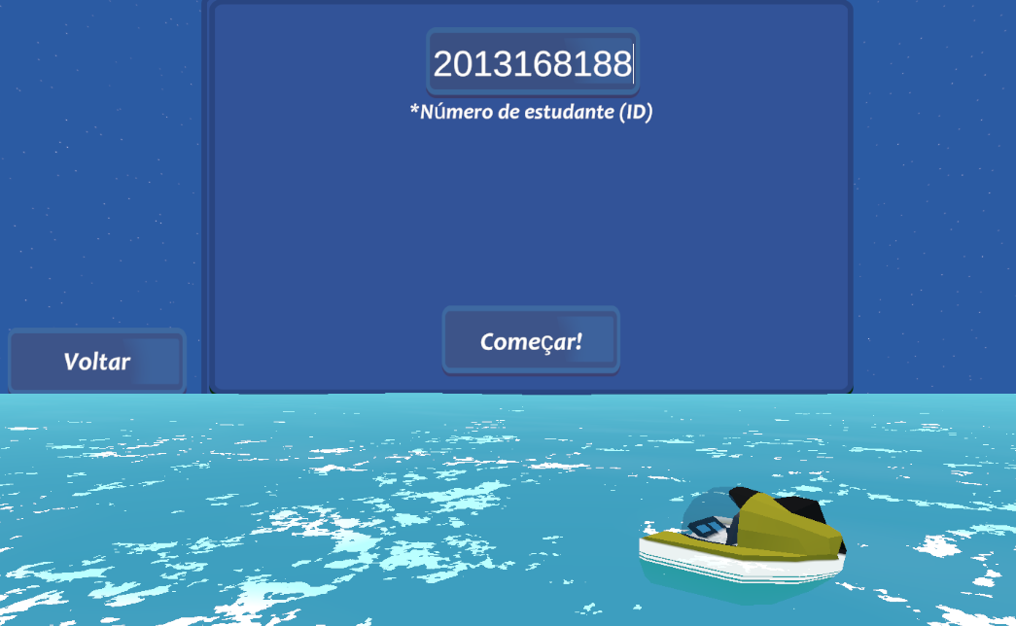

Figure 2.1: Main menu of Misterios Aquaticos game

## Design choices

The game was designed to create a relaxed and immersive experience, fostering a sense of security and tranquillity. A low-poly asset bundle was chosen not only for its aesthetic appeal but also to reduce performance impact, ensuring smoother gameplay.

## Optimization techniques

Optimization is crucial in game development to ensure smooth performance, especially on lower-end devices. A well-optimized game maintains a stable frame rate and provides a better player experience.

There are various ways to optimize a game, including efficient programming techniques, strategic asset management, and proper use of Unity’s built-in tools. For *Mistérios Aquáticos*, several key optimization techniques were applied to enhance performance.

### Unity Profiler

A fundamental step in optimization is identifying performance bottlenecks—whether they stem from CPU or GPU usage.

* CPU (Central Processing Unit): Handles game logic, animations, physics, and scripts. Performance-heavy elements include *Update* methods, coroutines, animations, shadows, and physics calculations.
* GPU (Graphics Processing Unit): Responsible for rendering everything on-screen. High-poly models, complex textures, and excessive draw calls can impact GPU performance.

The Unity Profiler was used to analyse these factors, helping to fine-tune the game’s performance by balancing CPU and GPU workloads efficiently.

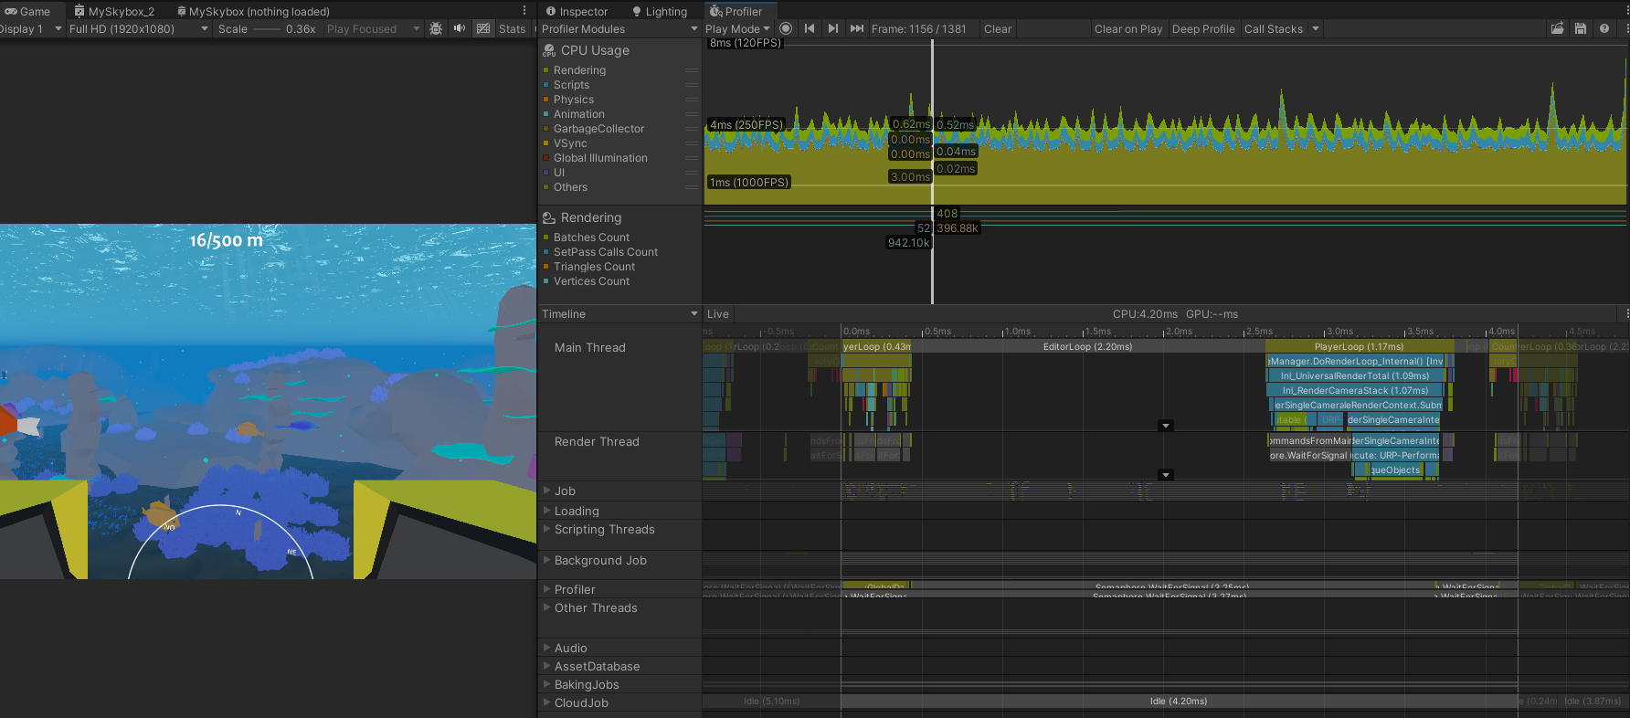

Figure 2.2: Unity profiler holds a variety of information related to the game performance.

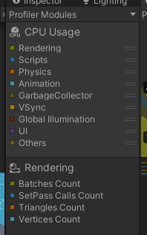

Figure 2.3: Modules of the profiler. These modules can be activated or deactivated.

For CPU we could find a spike and analyse it carefully

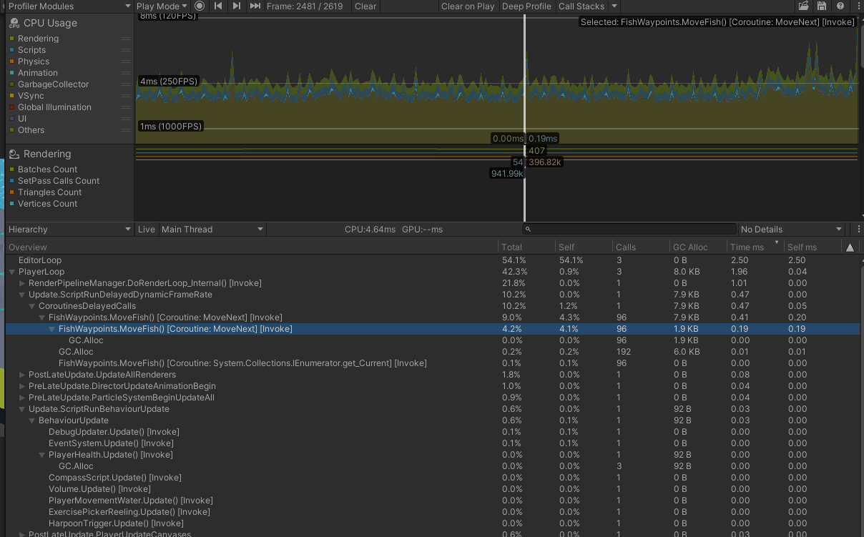

Figure 2.4: Finding a spike in the profiler and checking the hierarchy for more information on the spike.

In the Unity Editor, the EditorLoop’s effects can be disregarded since they don’t affect the final build. However, a closer look at the PlayerLoop shows that both FishWaypoints.cs and PlayerHealth.cs use a substantial amount of memory and account for most of the function calls. For GPU rendering, it’s important to adhere to optimal values, particularly regarding Set Pass calls.

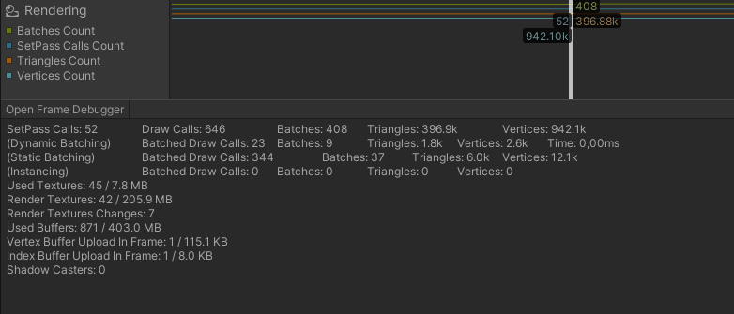

Figure 2.5: Rendering module in Unity profiler. It can be used to understand performance issues related to rendering.

Opening Frame Debugger allows examining how Unity draws the scene [2.6].

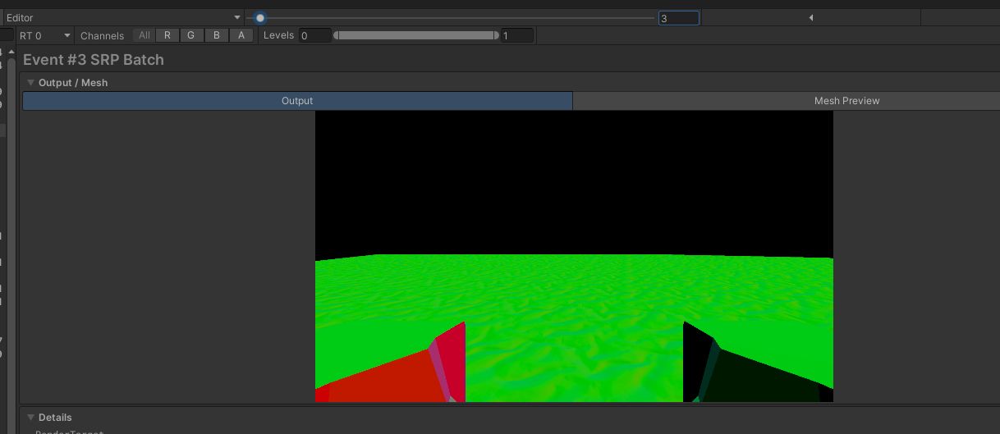

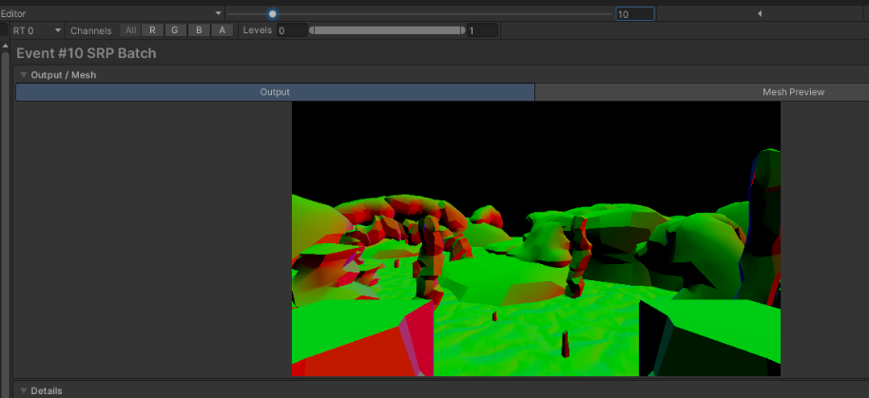

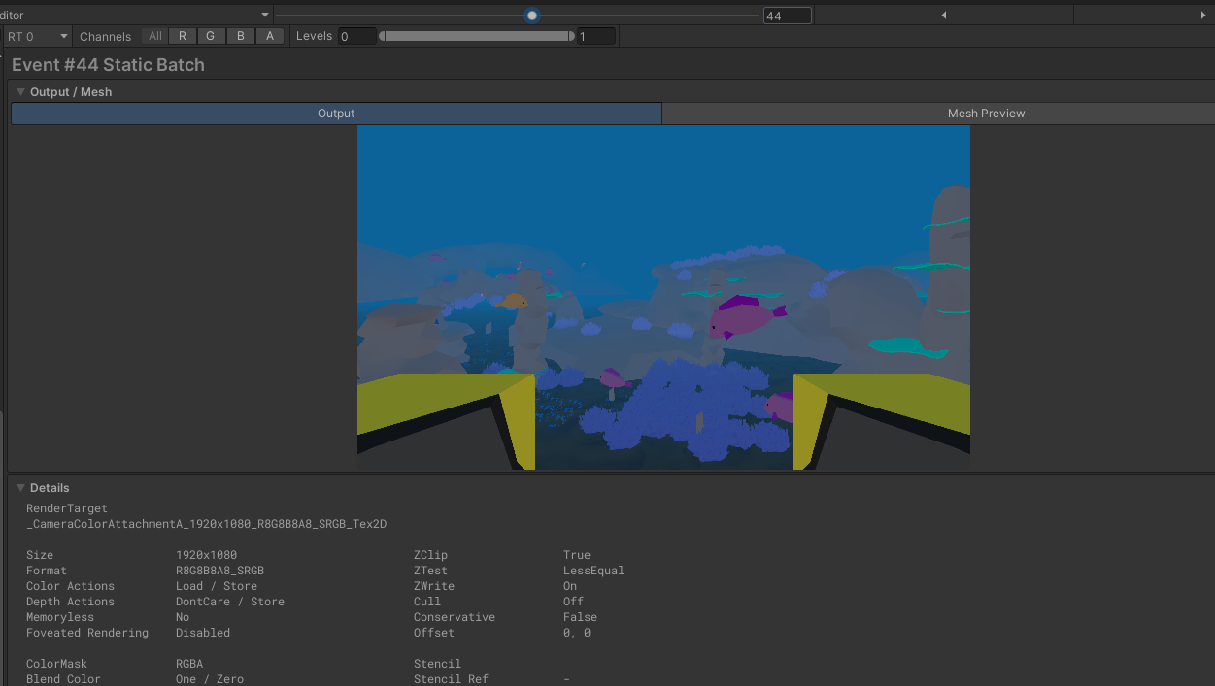

Figure 2.6: Unity frame debugger. Each event shows how the scene is being rendered.

The URP is responsible for what the main camera is rendering, while the UGUI is being rendered in the Canvas [2.7].

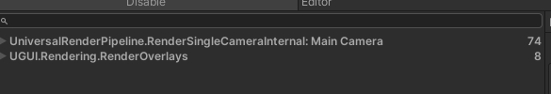

Figure 2.7: Expanding each item gives access to information related to scene objects that are being rendered.

### Combining static meshes

Draw calls are instructions sent to the GPU, and reducing their number is essential for performance. One optimization technique is static batching, where objects marked as static in Unity are combined into a single draw call. However, this only works if:

* The objects share the same material.
* The objects do not move, as static batching prevents movement.

If an object has multiple materials or if there are too many separate objects, Unity cannot batch them efficiently, increasing draw calls.

### Baking lights

Lighting is computationally expensive, particularly real-time lighting, which calculates shadows and reflections dynamically. This prevents Unity from combining meshes efficiently.

A solution is baking lights, which precomputes lighting information into lightmaps. These lightmaps store the lighting details for static objects, drastically improving performance. However, baked lighting means new light sources won’t affect the scene dynamically.

### Object pooling

Since the game involves spawning and removing many fish, using Destroy() and Instantiate() frequently is inefficient. Instead, object pooling is used:

* Fish are instantiated only once.
* When a fish is removed, it is deactivated instead of destroyed.
* When a new fish is needed, an existing inactive fish is reactivated.

This significantly reduces performance costs by minimizing memory allocation and garbage collection.

### Vertex shaders

Animating fish with traditional bone-based rigs would require multiple bones per fish, increasing CPU usage dramatically. Instead, a vertex shader was used to animate fish using a sin wave applied directly to their vertices, offloading calculations to the GPU. This technique is commonly used for animating foliage, water, and other natural elements.

### Fog

Unity's camera has a rendering distance setting, which controls how far objects are drawn. A large draw distance wastes resources rendering objects the player may not even see. To counter this, fog is applied to obscure distant objects, allowing a reduced render distance without breaking immersion.

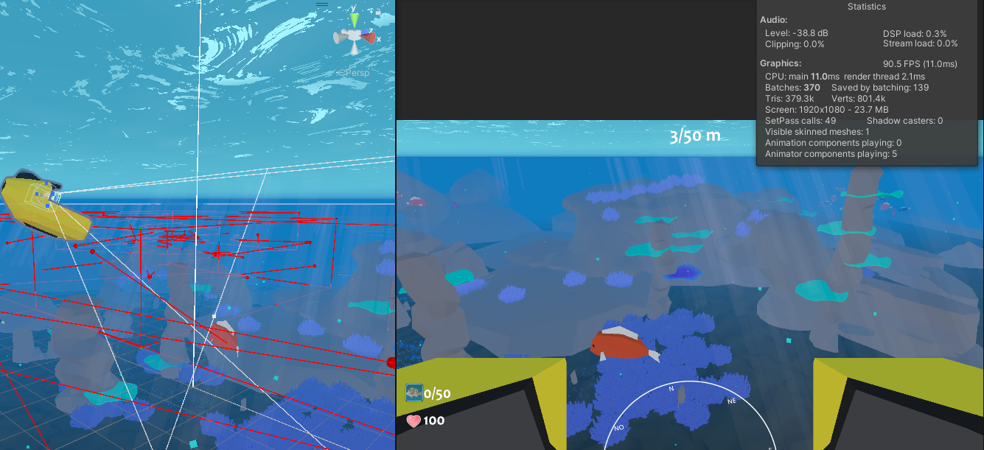

Figure 2.8: Fog distance is set at 300 units.

### Render distance

Objects that are far from the player don’t need high detail. LOD (Level of Detail) reduces the polygon count of distant objects, switching to higher-quality models only when the player moves closer. This significantly reduces GPU workload.

### Limited Drawing

Since underwater and land environments are separate, the game deactivates all underwater objects when the player is on land. This reduces processing overhead and improves performance. Image [11] demonstrates the difference between limited and non-limited drawing.

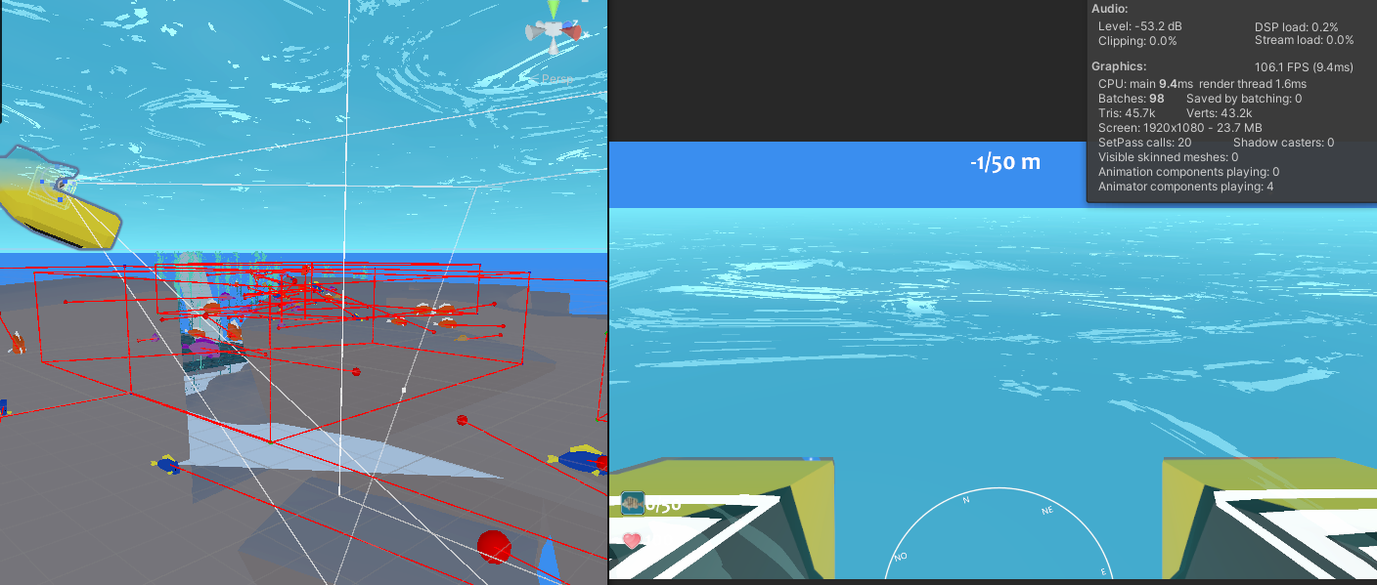

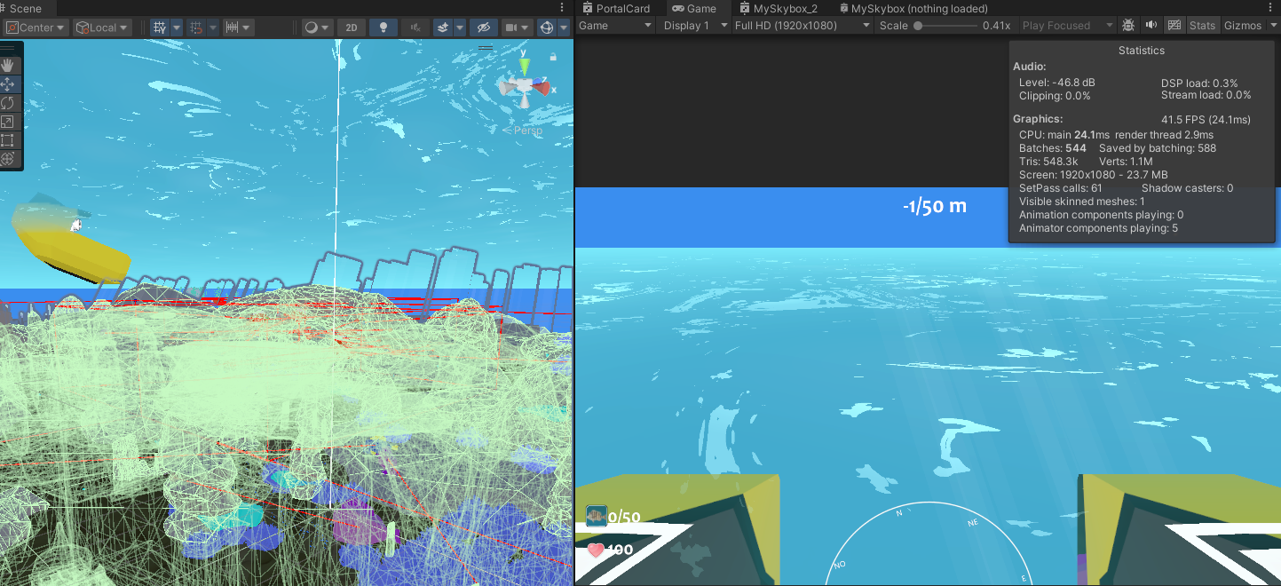

Figure 2.9: Difference between keeping the underwater objects active and deactive when player is in shore. Just because the player cannot see them, the objects are still being rendered.

## Shaders

Shaders control how materials appear in the game, affecting reflections, lighting, and transparency. Unity supports HLSL (High-Level Shader Language) for shader programming, but for easier development, ShaderGraph can be used.

A key challenge in Mistérios Aquáticos was applying underwater fog. Unity’s default fog applies based on distance, but since the skybox is rendered at infinity, it was unaffected, creating an unnatural look. By using ShaderGraph, a custom shader was created to properly apply underwater fog, improving immersion.

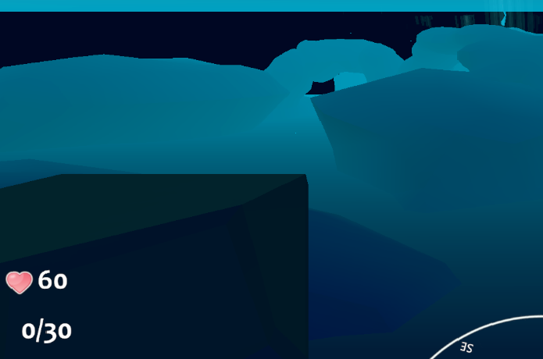

Figure 2.10: Before and after applying the shader to the skybox.

The colour of the background will change accordingly to the fog colour in the current zone, producing the desired effect. The code looks like the following:

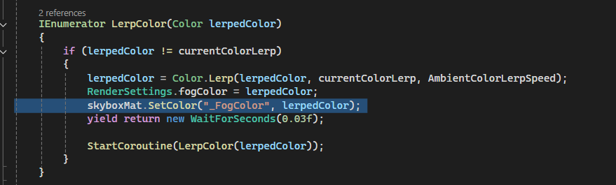

Figure 2.11: Code responsible for lerping the colors of the ambient. When the ambient theme changes, the player will see a smooth transition of underwater colors.

The ShaderGraph corresponding for this behaviour looks like the following:

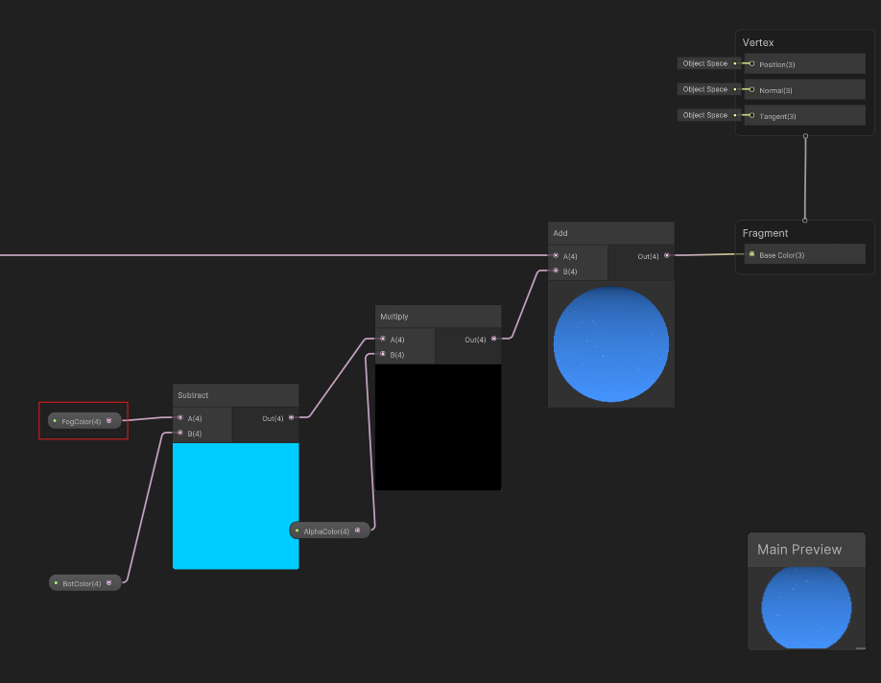

Figure 2.12: Section of the shadergraph responsible for adding color to the skybox.

Within this shader, we also generate the stars in the sky. The number and size of the stars can be adjusted, allowing for customization. A noise filter is applied to the stars, which moves over time, creating a subtle twinkling effect. The rest of the shader structure looks as follows:

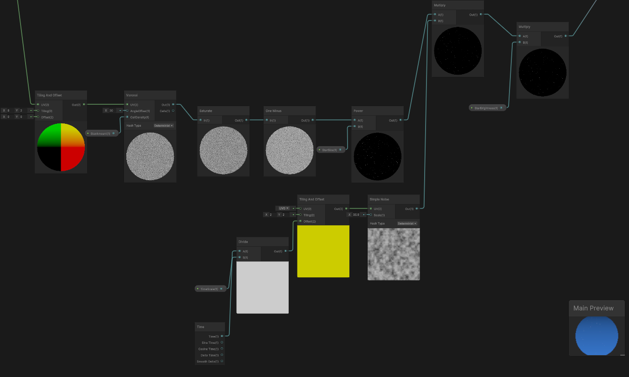

Figure 2.13: Section of shadergraph responsible for adding stars and shine effect.

By tweaking the shader parameters, it is possible to tune the appearance to achieve the desired effect.

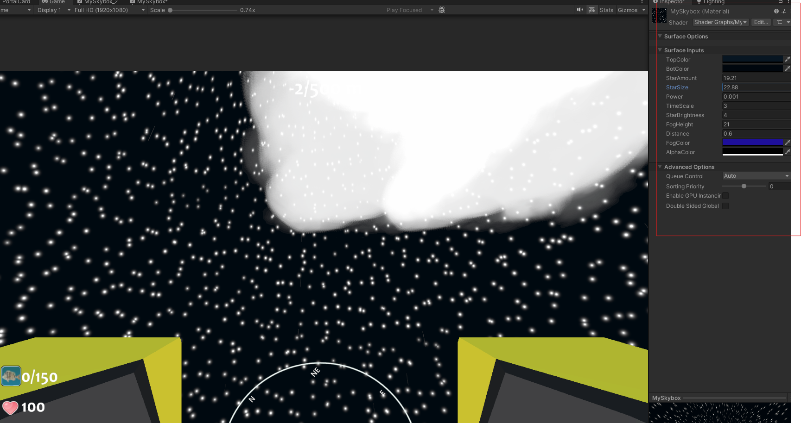

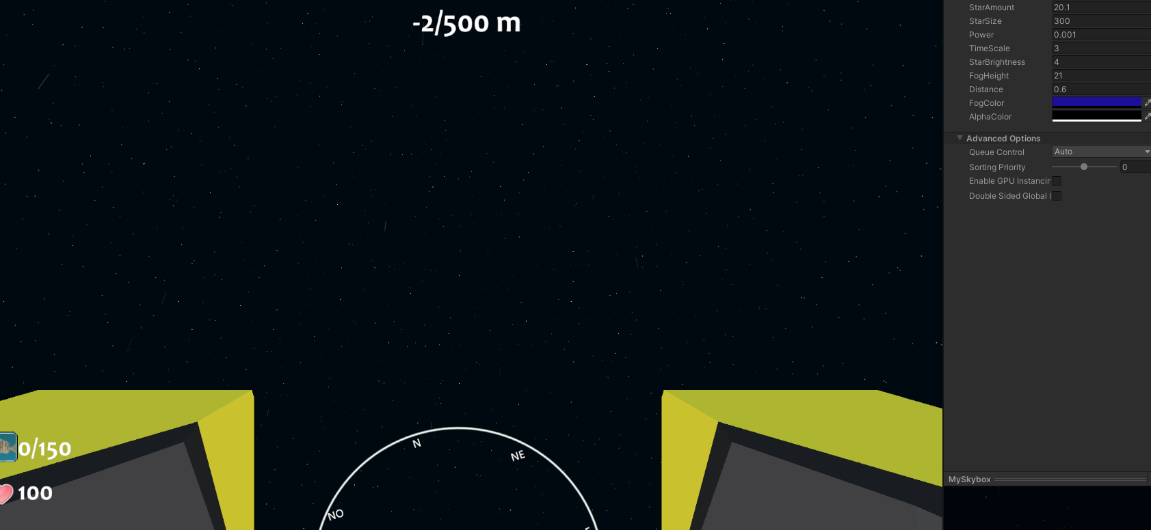



Figure 2.14: Different combinations of values affecting the sky.

## Player engagement

Player engagement is crucial, especially when the objective of the game is to make the player play for as long as possible. This is usually done by offering more game feedback, which is fundamental in captivating players and enhancing their overall experience. This feedback can come from various sources, such as ambient design, sound effects, and particle systems. Essentially, anything that potentially contributes positively for the player experience by making it more immersive and engaging can be considered game feedback.

### Sounds

Sound plays a vital role in shaping a player's experience. It provides crucial feedback and enhances immersion. While often overlooked, its absence can have a negative impact on gameplay and experience.

*Mistérios Aquáticos* implements sound carefully to create a more dynamic world. Some key examples include:

* The Seamoth’s engine sound, which gradually increases in volume when accelerating and fades when stopping.
* A music manager script that plays music at random intervals, ensuring a minimum five-minute gap between tracks to prevent repetition and fatigue.

### Particles

Particle effects enhance visual feedback and contribute to an engaging experience. In *Mistérios Aquáticos*, particles are used to improve immersion:

* Water splashes and bubbles appear when the Seamoth submerges or surfaces.
* Additional effects simulate environmental interactions, reinforcing the underwater atmosphere.

### Ambient

The atmosphere of a game greatly influences how immersive it feels. In *Mistérios Aquáticos*, several environmental details enhance the sense of being underwater:

* An ecosystem featuring fish, stones, and marine life populates the world.
* Dynamic weather conditions add variety to the experience, including:
  + Clear sky
  + Clear night (randomly with aurora)
  + Rainy cloudy night
  + Cloudy night
  + Cloudy day

Each time of day has its own distinct water and ambient colour settings, further immersing the player in different moods and experiences.

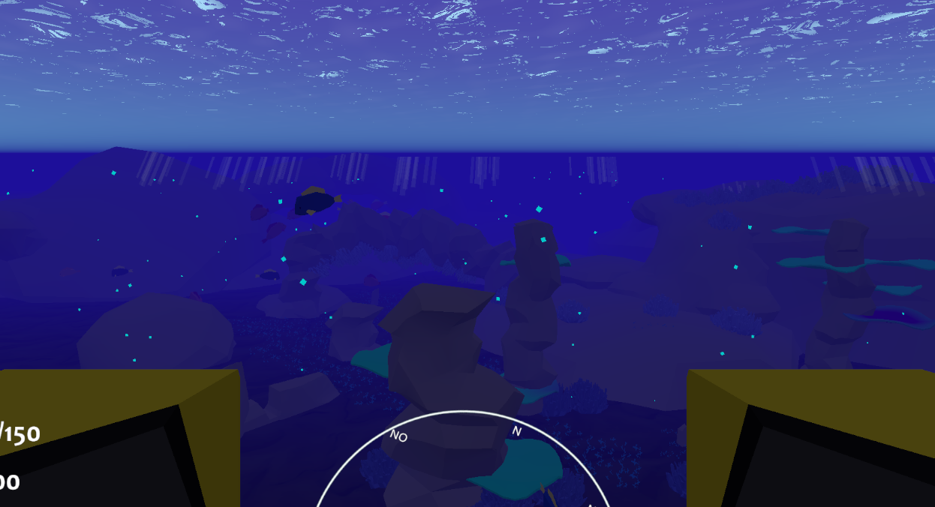

Figure 2.15: Nighttime in safe zone.

### Tutorial

Given the complexity of the game, a tutorial is essential to guide new players. The tutorial introduces the core mechanics and provides a brief tour of the island, ensuring players understand their objectives.

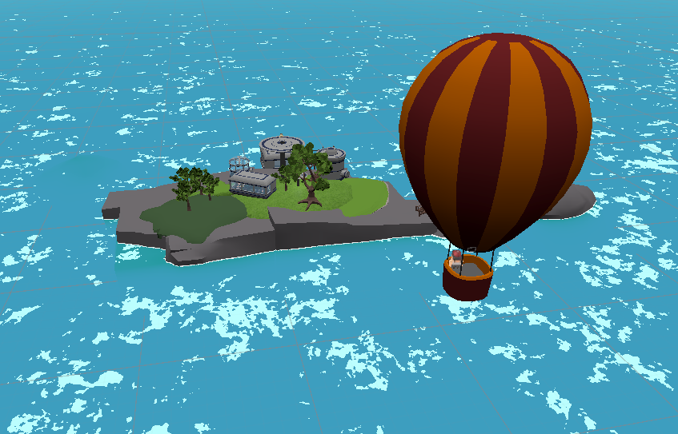

Figure 2.16: Game Island.

While most buildings on the island serve only aesthetic purposes, the engineering facility plays a functional role. These structures help populate the world, making it feel more alive and providing a sense of presence.

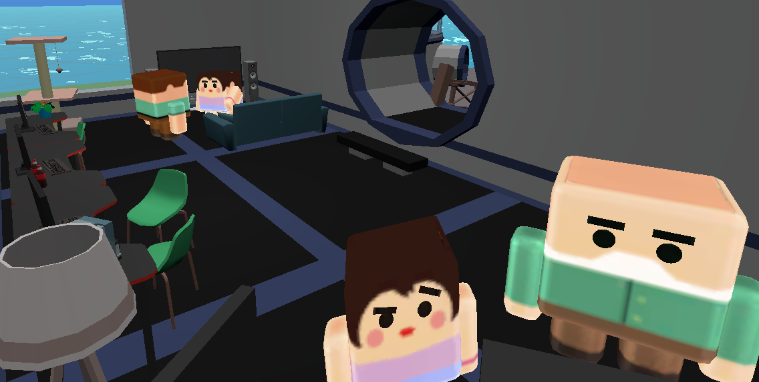

Figure 2.17: Living room in the game. It has no purpose besides giving the player a sense of company.

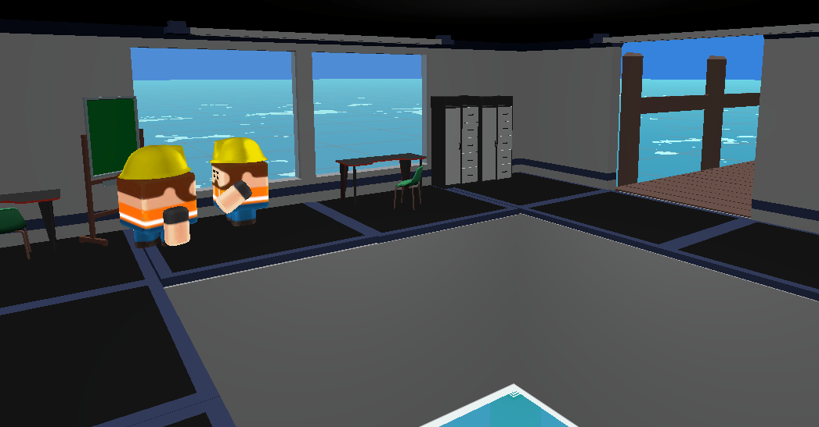

Figure 2.18: Engineering room. Where the player can buy modules to progress in game.

### Zones

Humans are naturally curious, which is why exploration plays a key role in *Mistérios Aquáticos*. By introducing distinct zones, each with unique themes and valuable fish, players are encouraged to venture further. Some areas contain rare items and achievements, rewarding exploration and maintaining player motivation.

The game world consists of seven distinct zones, each offering a different experience:

1. Safe Zone – The starting area, featuring calm blue waters, a stable temperature, and low-value fish. No upgrades are required to explore this zone.
2. Coral Zone – A greenish reef teeming with marine life and mid-tier fish.
3. Deep Zone – A darker, more mysterious area with rare and valuable fish and a shipwreck containing a lost jewel.
4. Base Zone – The player’s home base, serving as a hub for upgrades and preparation.
5. Ice Zone – A frozen landscape with unique aquatic life adapted to cold environments.
6. Lava Zone – A volcanic region with extreme conditions and high-reward fish.
7. Temple Zone – A hidden area containing a rare artifact.

Each zone presents new challenges and rewards, ensuring continued player engagement and progression.

#### Safe zone

The Safe Zone serves as the player's starting area, designed to offer a sense of security. It features calm blue waters, shallow depths, normal temperatures, and low-value fish. This zone is fully explorable without the need for any upgrades or modules.

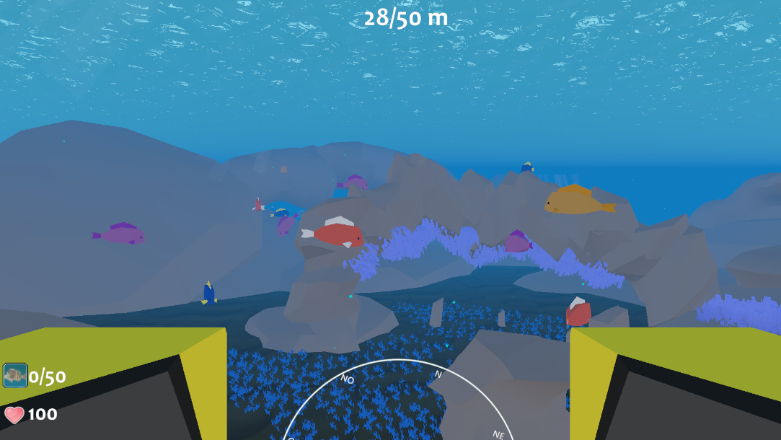

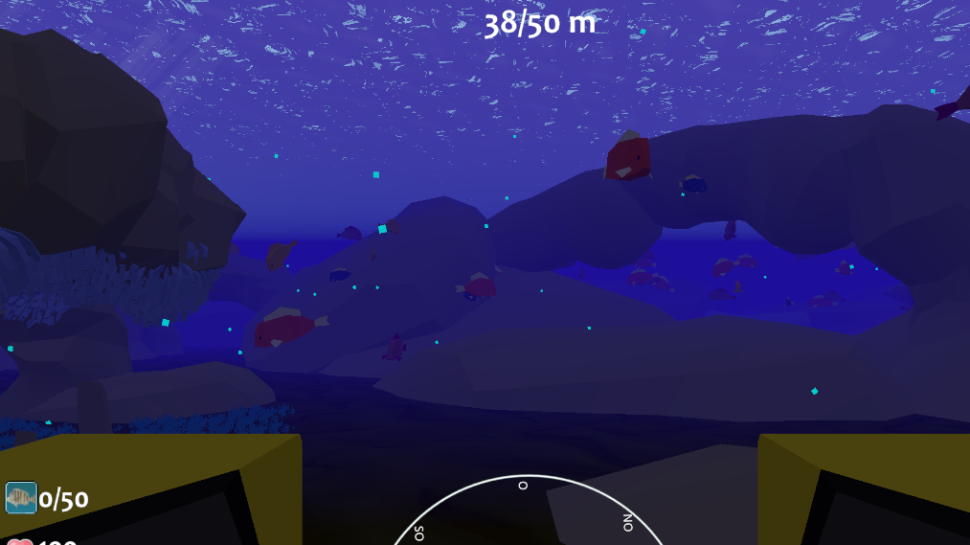

Figure 2.19: Day and nighttime in safe zone.

#### Coral zone

The Coral Zone, while initially intimidating, provides a sense of security once the player becomes familiar with its environment. This area is deeper than the Safe Zone and has a greenish hue, with dense kelp forests offering shelter. The zone also contains a rare item, the Ancient Coral, which can only be collected with a fully upgraded storage module.

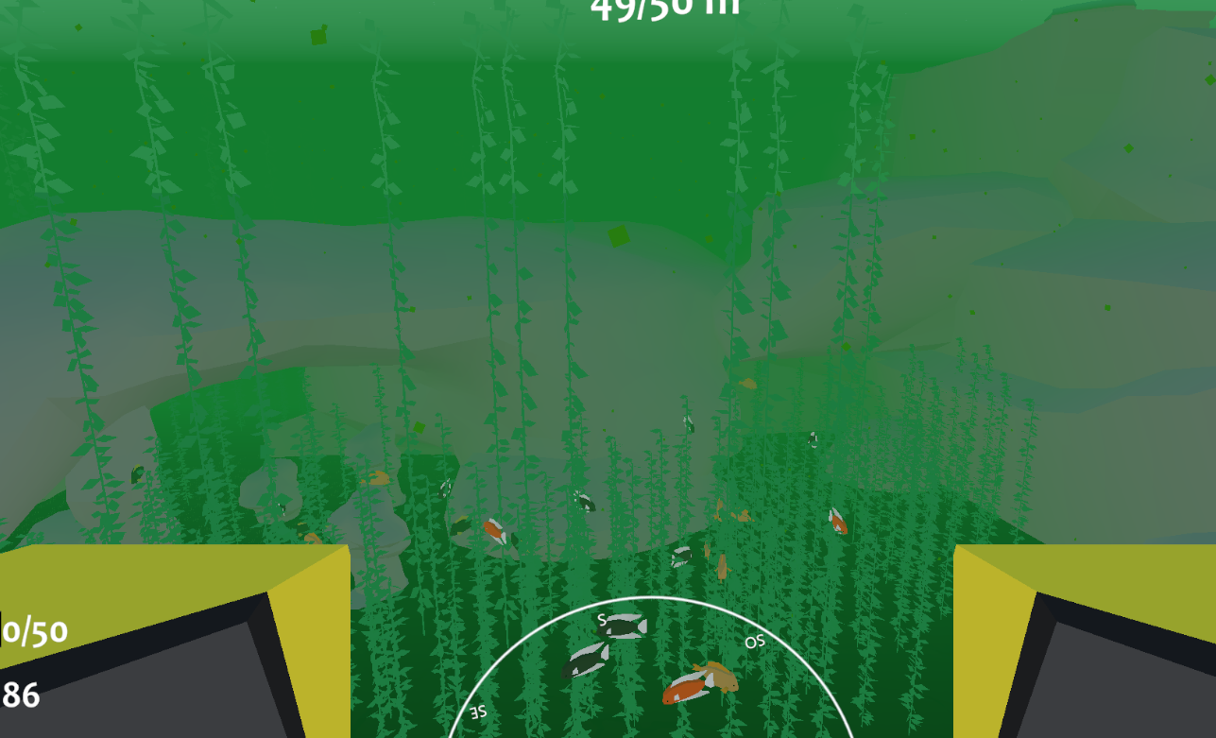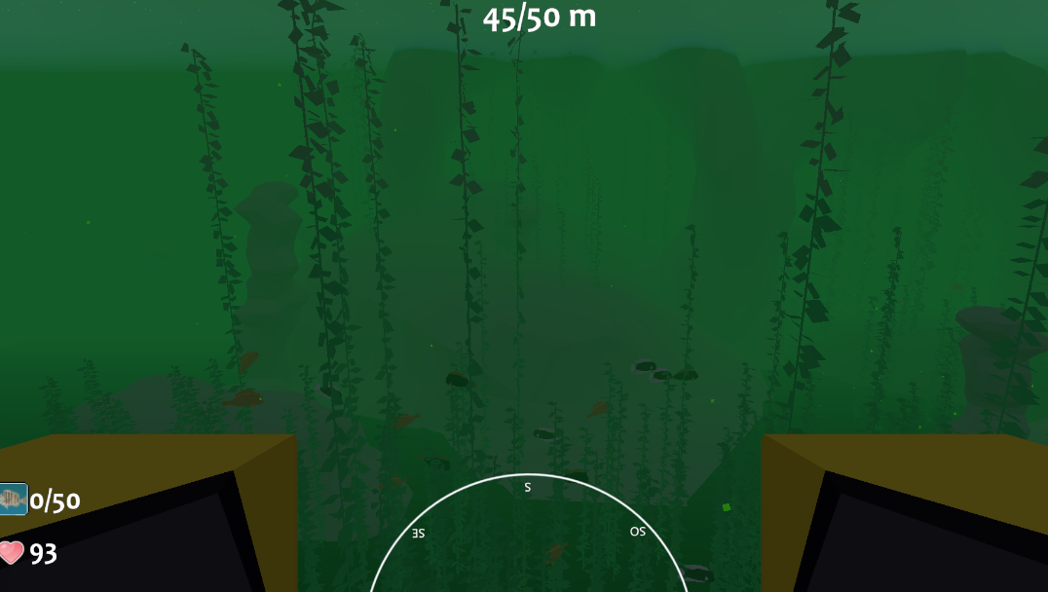

Figure 2.20: Day and nighttime in Coral zone.

#### Deep zone

One of the deepest regions in the game, the Deep Zone is home to a shipwreck and a rare gem. Due to the extreme depths, players must have a level three depth module to prevent the Seamoth from breaking under pressure. Additionally, a flashlight is necessary for navigation, as visibility is significantly reduced.

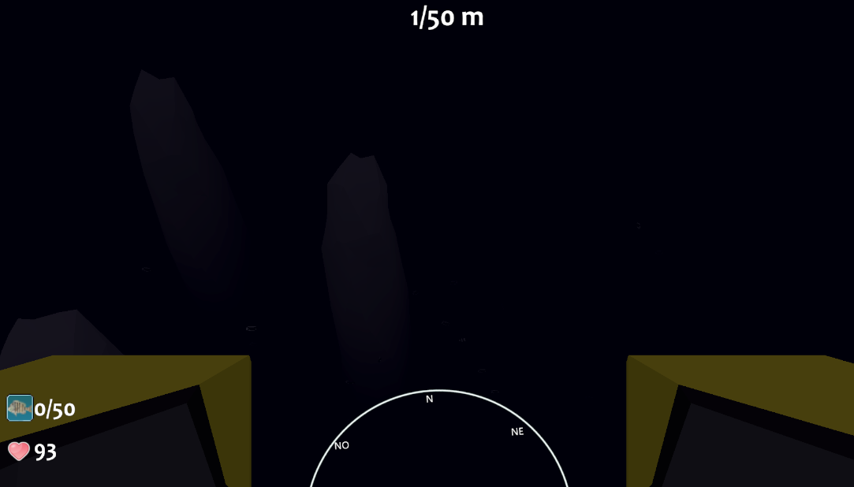

Figure 2.21: Day and nighttime in Deep zone.

#### Base zone

The Base Zone features a hidden underwater base, accessible only with a flashlight module due to the darkness of the depths. Players can explore the base’s interior, where they will discover a secret item. a flashlight is necessary for navigation, as visibility is significantly reduced

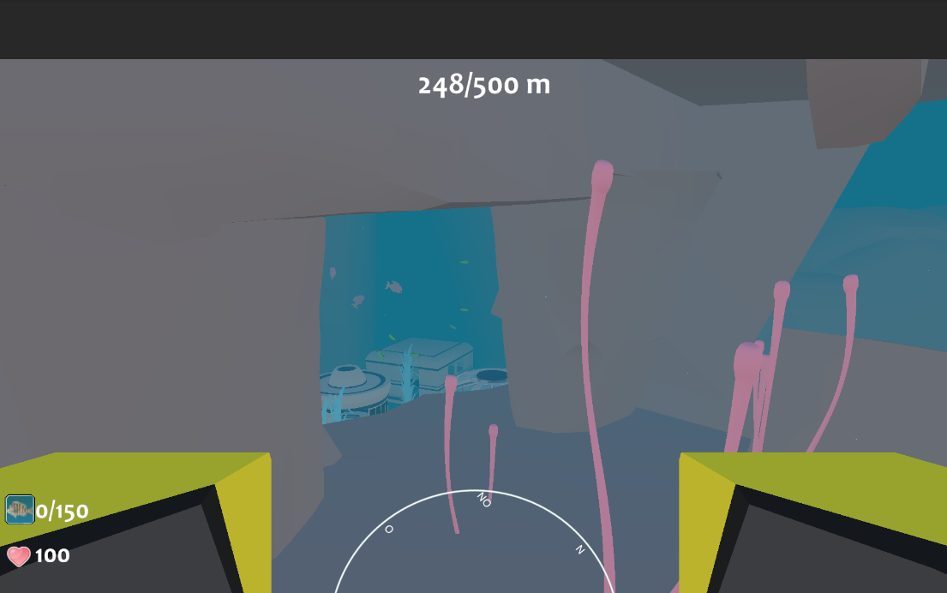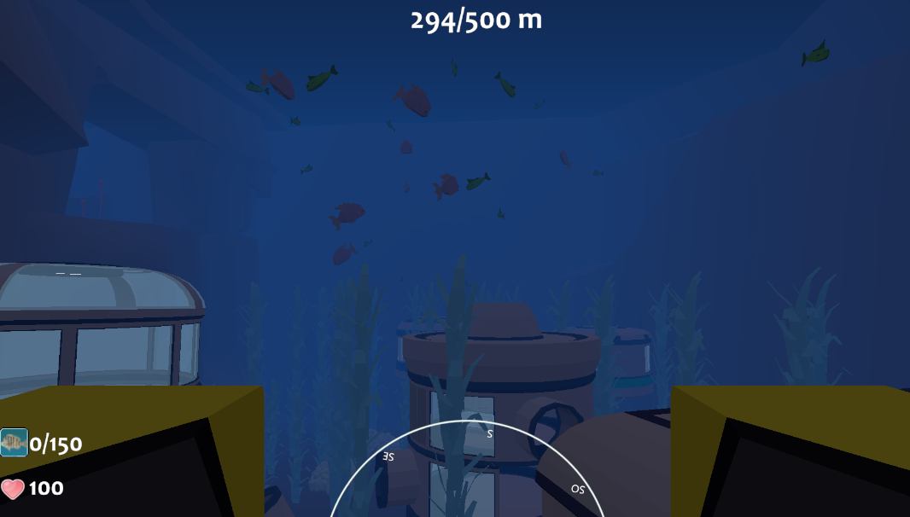

Figure 2.22: Day and nighttime in Base zone. The structure can be explored and holds a rare item.

#### Ice zone

The Ice Zone is a freezing environment that requires players to have at least a level one temperature module to explore it safely. It holds a secret item in its depths.

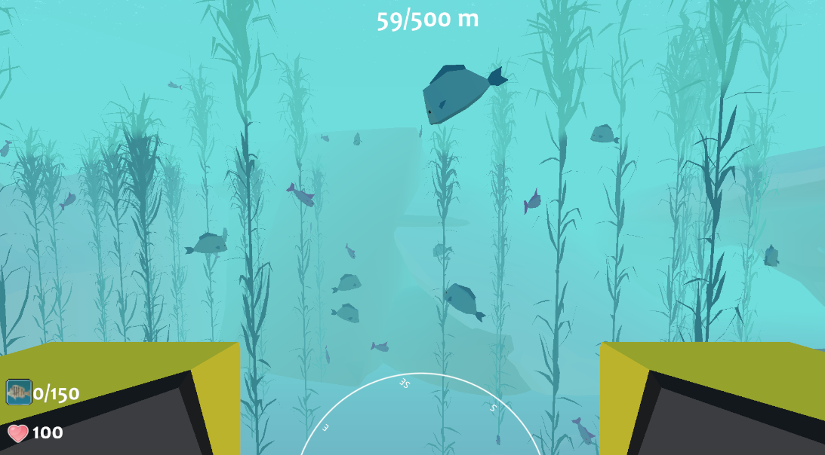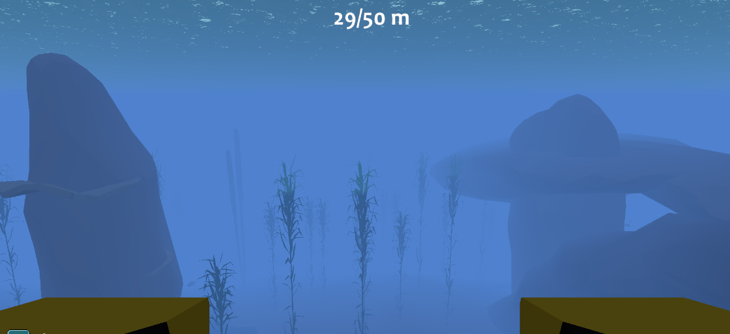

Figure 2.23: Day and nighttime in Ice zone.

#### Lava zone

The Lava Zone is one of the most extreme environments in terms of temperature. To survive in this area, players must have a level two temperature module equipped.

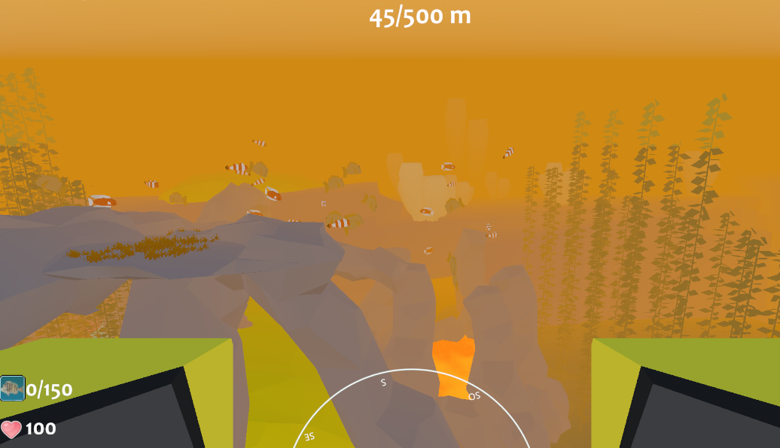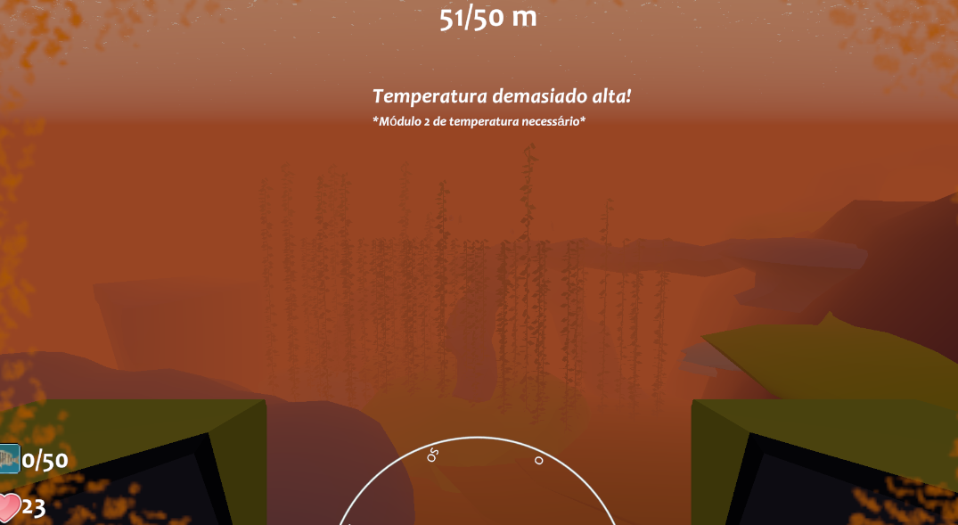

Figure 2.24: Day and nighttime in Lava zone.

#### Temple zone

The Temple Zone is a hidden region located beneath the Lava Zone. To access it, players must have:

* A flashlight module
* A level two temperature module
* A level two depth module

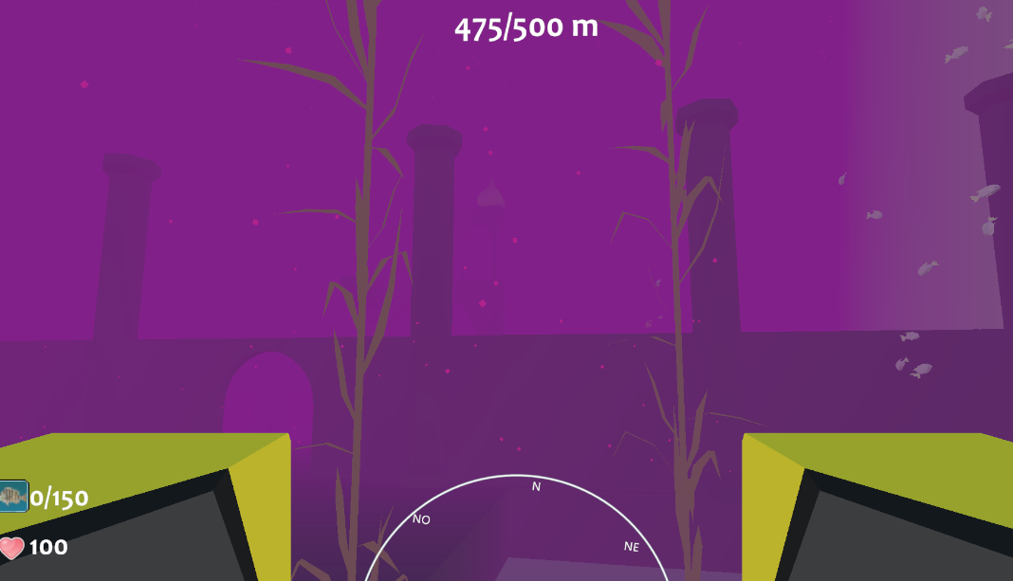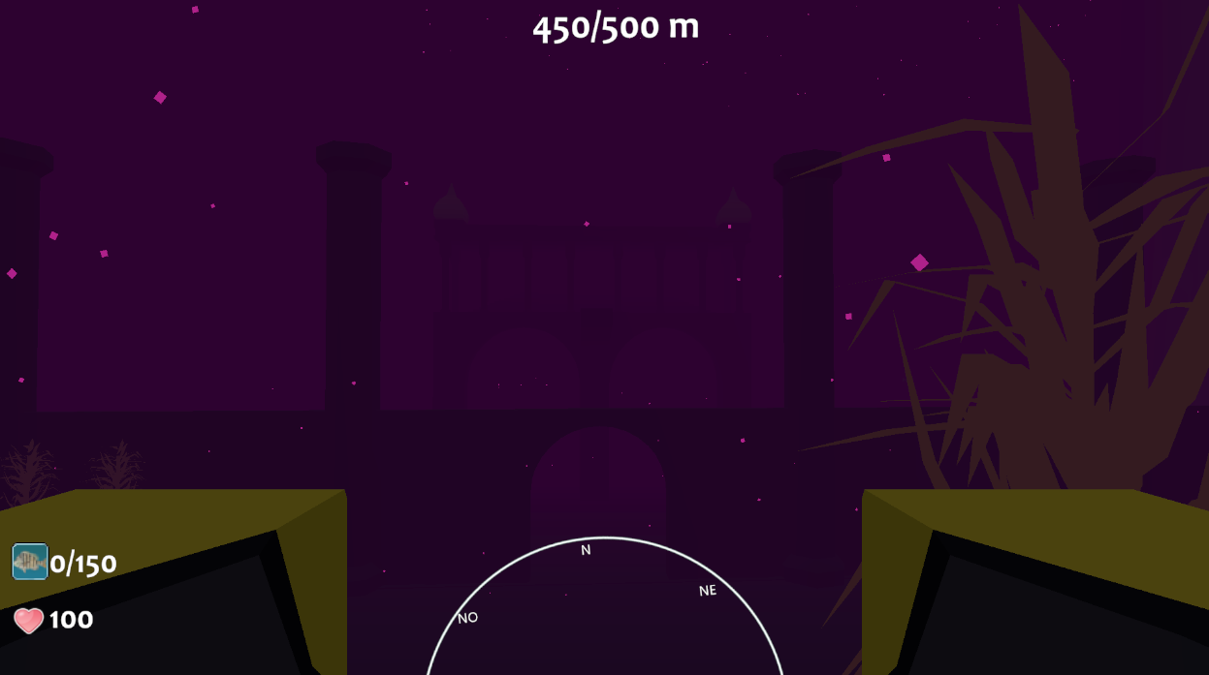

Figure 2.25: Day and nighttime in Temple zone.

### Achievements

Achievements work as a motivation, so players keep playing the game for a specific objective. Players unlock these milestones by discovering new locations and collecting rare items, providing a sense of accomplishment.

### Unlockables

While all zones are technically accessible from the start, progression requires unlocking the necessary modules. Without these upgrades, deeper exploration becomes impossible, and pushing forward without them will result in catastrophic failure of the Seamoth, requiring rescue.

Upgrades can be purchased from the in-game store using coins, which players earn at the end of each day by catching and selling fish. Players can store fish in either:

* Their personal inventory
* An underwater storage unit, managed by two divers who assist in holding extra fish

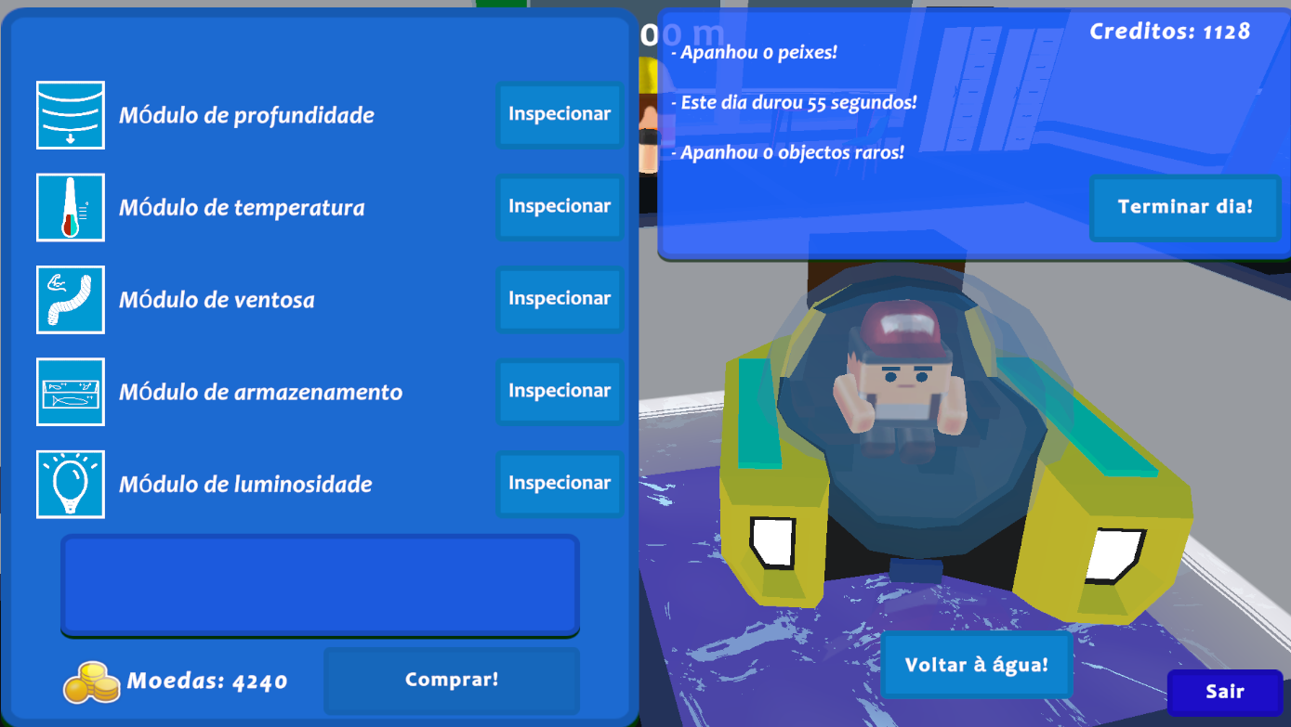

Figure 2.26: When the player approaches the engineering room, it will be brought to the surface of the room. Here it can buy and upgrade modules so it can go further in the game. It also shows some stats related to the day it played.

Each upgrade visually alters the Seamoth, ensuring that players can immediately recognize their improvements.

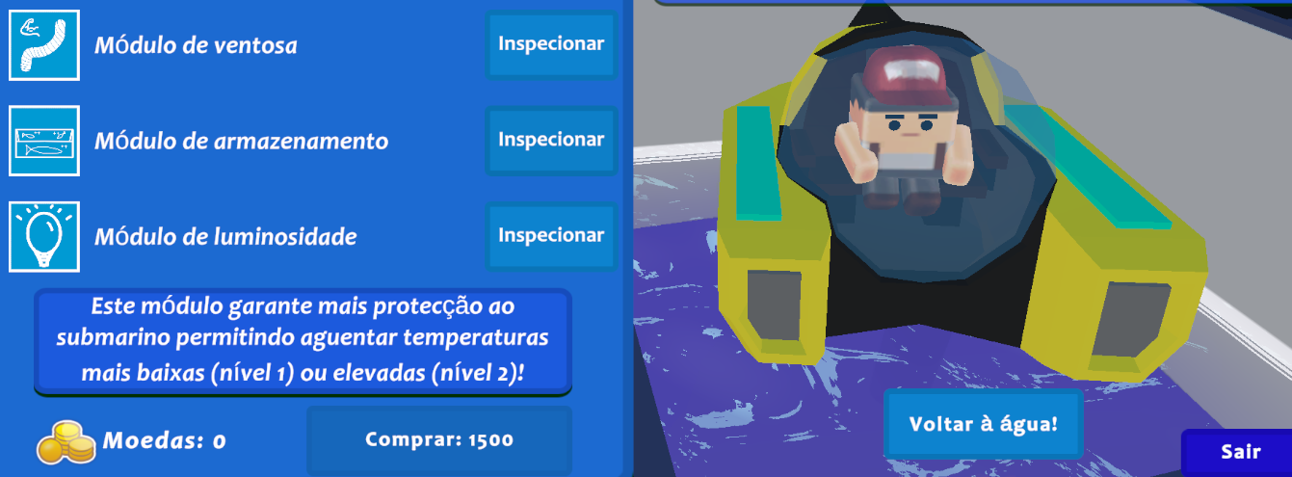

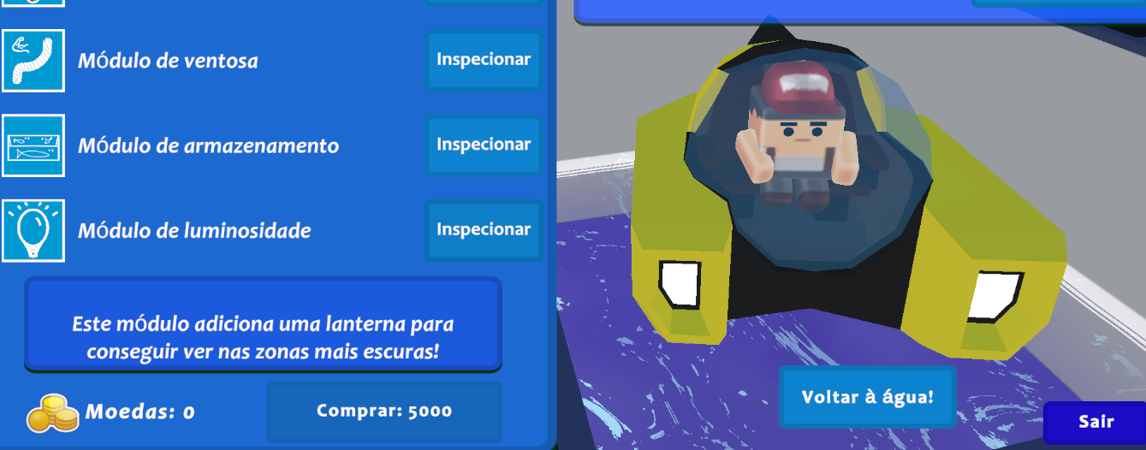

Figure 2.27: Each module upgrade affects the visual of the seamoth. These two images show the different stages when the flashlight and temperature modules are selected, while having none upgraded. The flashlight modules, when selected, alters the appearance of the headlights, giving them a white colour. While selecting the temperature module, adds two blue stripes on the sides. Each module has a specific characteristic that also changes according to the level it is.

#### Saving

Progress is saved automatically when the player terminates a day. At the end of each day, the game updates the player's current state, including:

* Credits & coins
* Fish caught
* Module upgrades
* Total time played







Figure 2.28: When terminating the day, the game progress is saved. These images show the API calls that are being made to the backed.

## Player retainability

### Day streak

To encourage consistent play, a streak bonus system rewards players with extra credits for consecutive days played. The default values are:

* First day streak – 25% bonus credits and coins
* Second day streak – 50% bonus credits and coins
* Third day streak - 100% bonus credits and coins

These values are modified in scripts, prior building the game.

### Meaning progression

A key reason players remain engaged is the sense of progression. *Mistérios Aquáticos* provides ongoing motivation by offering:

* New zones to explore
* New fish species to discover
* Upgrades to unlock

Each newly discovered area introduces fresh elements, keeping the experience exciting and rewarding.

### Game credits

Credits can be earned through collecting coins, collecting achievements, or performing exercises while catching fish. The number of credits awarded is fully configurable. These game credits can be used for real-world rewards and should not be mistaken with coins, which is the game currency used to improve the seamoth.

## Scalability

The game was designed to be dynamic, making it easy to expand. The system allows for seamless additions of new fish species and spawn points. The red line volumes in the development image [3.29] indicate different fish spawn locations, ensuring balanced distribution.

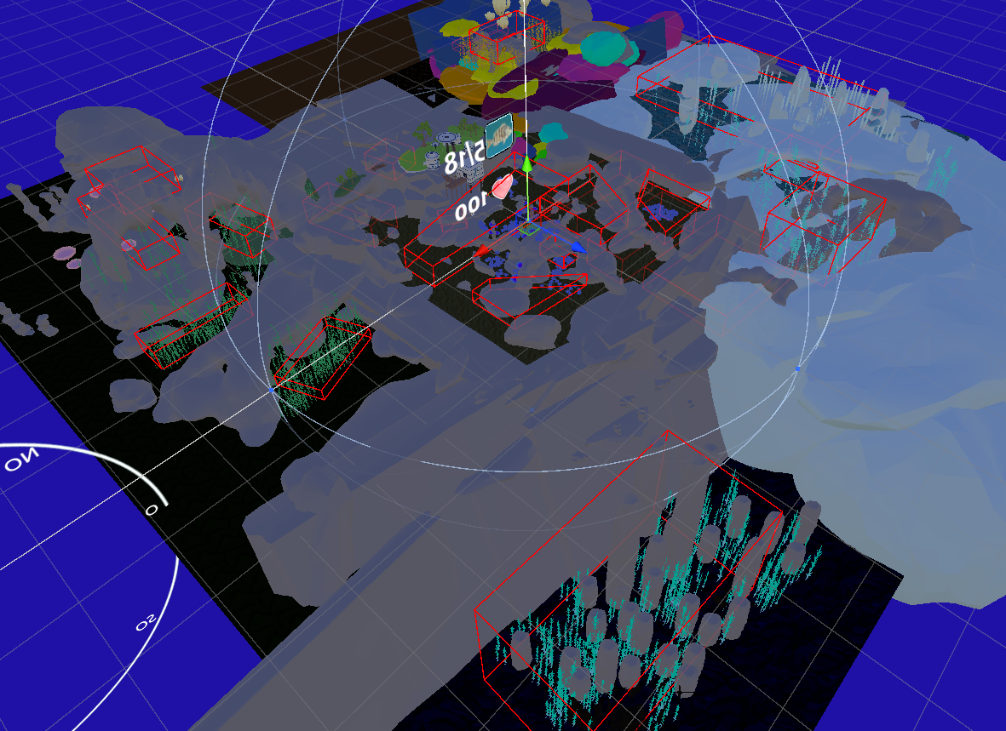

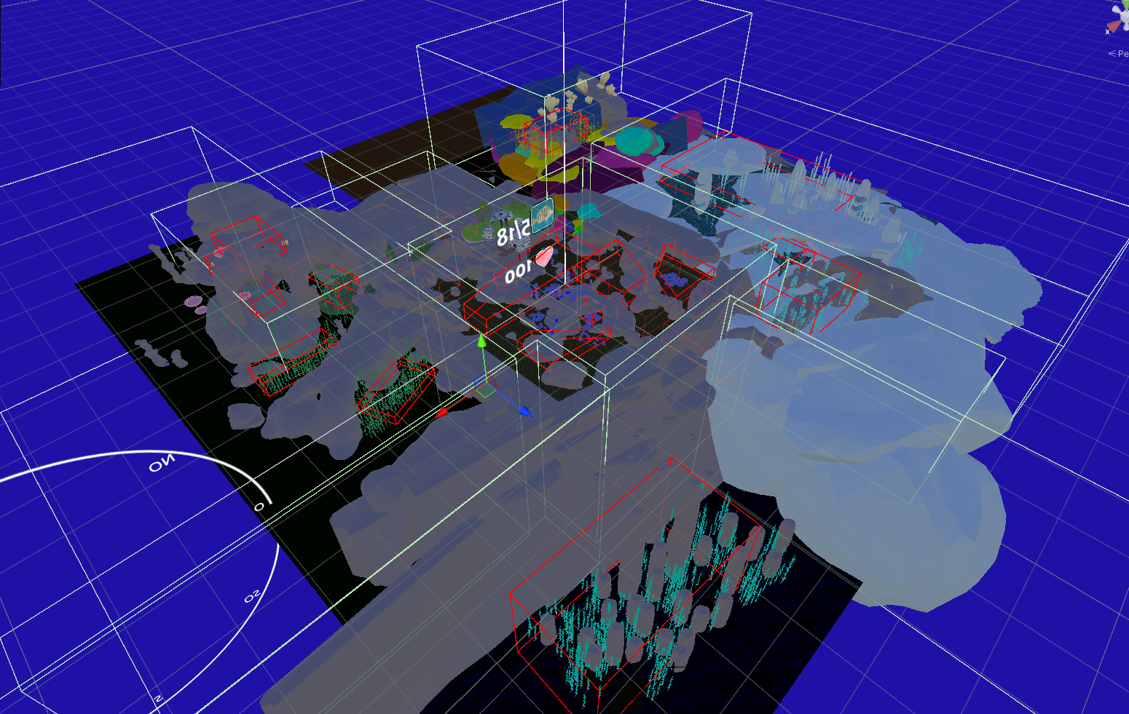

Figure 2.29: Full map of Misterios Aquaticos with the different zones highlighted.

### Creating new zones

While new zones can be added, the initial development did not prioritize their expandability, making the process less intuitive. Each zone operates using a dedicated script that identifies its boundaries. Because zones are deactivated when not in use to optimize performance, new zones must be integrated carefully by:

1. Creating a new collider to define the zone’s boundaries
2. Adding the new zone to the *ZonesScript.cs*
3. Setting its Boolean activation state

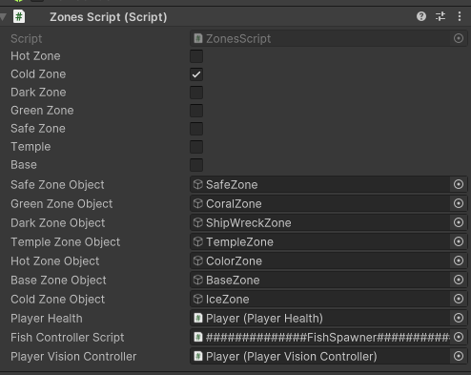

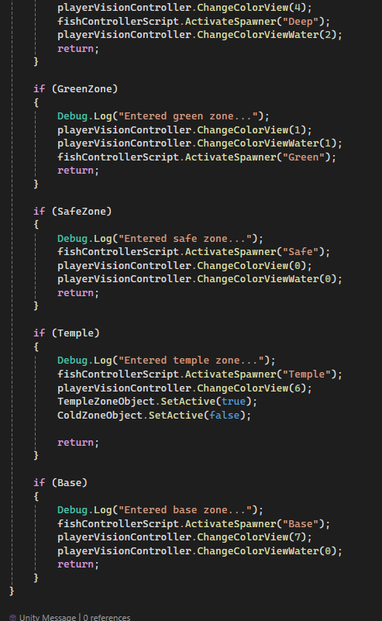

Figure 2.30: Process of creating zones.

### Creating new fish spawn volumes

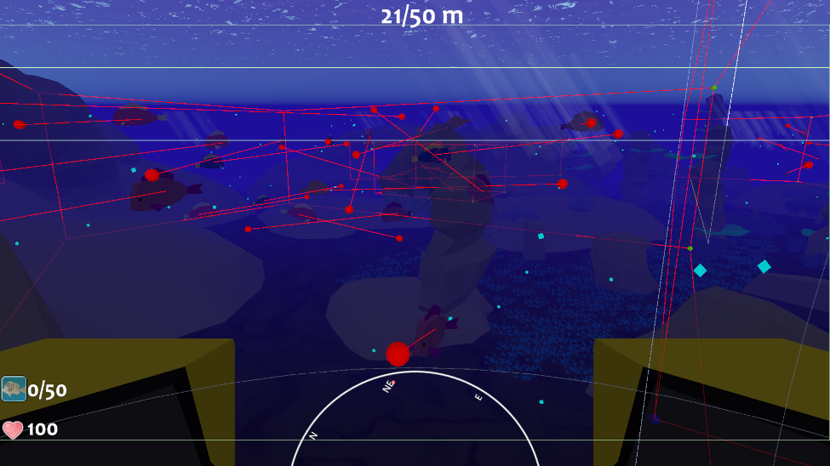

Figure 2.31: A volume in the Safe zone showing the fish waypoints.

The process of creating new fish spawns was designed to be intuitive and scalable. Each zone spawn object is equipped with a fish spawner script, as shown in Figure [2.32]. This object acts as the parent, with two types of child objects.

The first child is the fish pool object [2.36], which contains the fish types to be spawned. This pool must be placed at the last child position index. The second child type is the volumes [2.34] representing volumes within the zone. For example, in Figure [2.33], five volumes are added to the safe zone, indicating five distinct locations where fish can roam.

Each volume must include the spawn points for the fish at the first position, followed by eight vertices, as depicted in Figure [2.33].

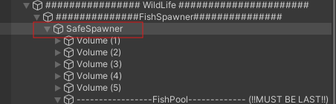

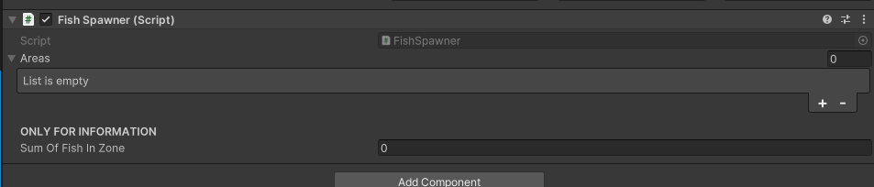

Figure 2.32: SafeSpawner object related to the safe zone spawn holds the Fish Spawner script.

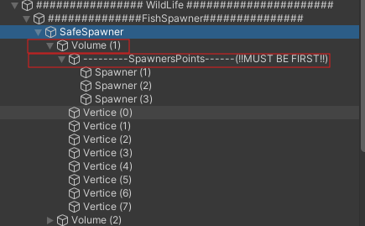

Figure 2.33: Each zone spawn holds several volumes, and each volume holds 8 vertices. These vertices make a volume.

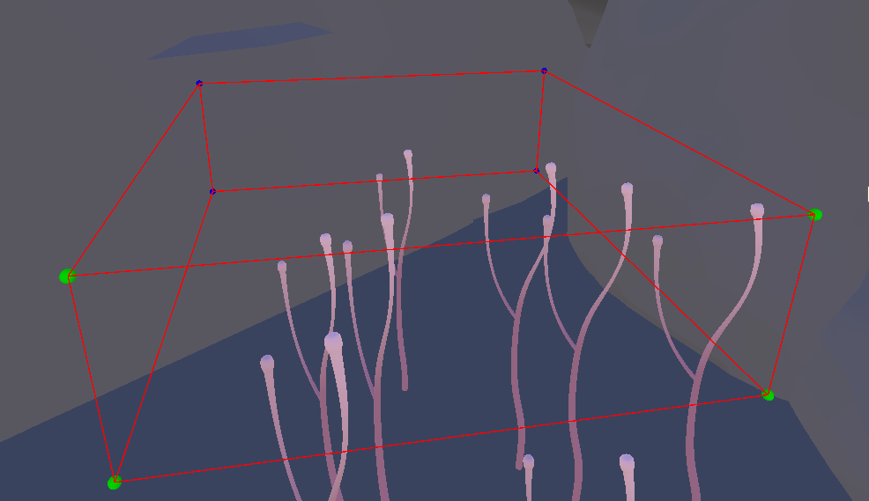

Figure 2.34: This image represents a spawn volume. The volumes have the FishSpawnerBoundaries.cs script attached to it. It is possible to choose the number of fish wanted in a volume and where the fish are spawned.

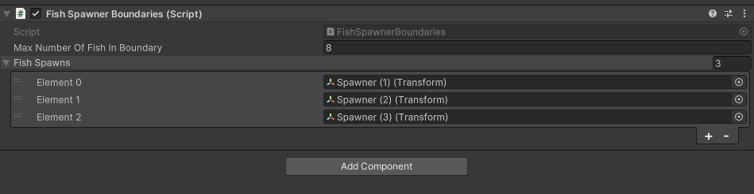

Figure 2.35: Script that holds the spawn points position of the fish.

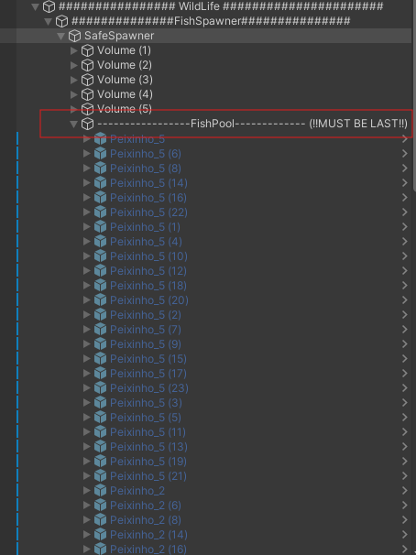

Figure 2.36: The last object in a zone spawn must be a fish pool. This fish pool object contains all the fish types as children that we want to spawn.

### Adding new fish species

Introducing new fish species is simple and efficient. Once a new fish model is created, the following steps are required:

1. Attach a collider (with the "Is Trigger" flag enabled)
2. Assign a Fish.cs script
3. Assign a FishWaypoint.cs script
4. Convert the fish into a prefab
5. Add it to the fish pooler for the zone where it should spawn
6. Define its size and in-game value

Each fish has a unique ID within the system, so care must be taken to ensure ID conflicts do not occur.

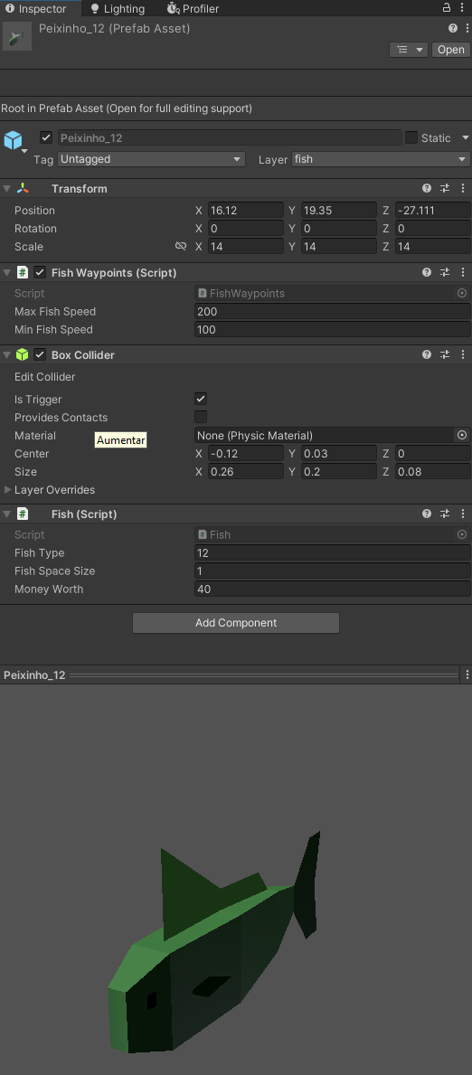

Figure 2.37: Components needed to add a new fish.

## Fish movement

Fish movement is very simple and effective. Each fish choses a random point in the volume of his spawn zone and goes there in a straight line. When he reaches its destination, a new waypoint is calculated.

## Adjusting values

Mistérios Aquáticos was developed using default gameplay values, which include parameters like store prices, player movement speed, fish speed, reeling speed, storage size, and more. However, to prevent unintended changes, some public variables that shouldn’t be modified were hidden from the Unity Inspector.

Adjusting in-game values is simple. Each script only exposes the relevant variables, using the [HideInInspector] tag to conceal any unnecessary ones, as shown in figure [3.38], ensuring a clean and focused interface in the Unity Inspector.

For instance, the shop manager script in the Inspector [3.37] allows the following adjustments:

* The number of credits earned from collecting coins.
* The number of credits awarded per fish caught or achievement unlocked.
* The prices of store upgrades.

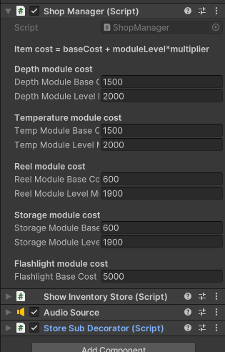

Figure 2.38: Shop manager script holding the costs of modules.

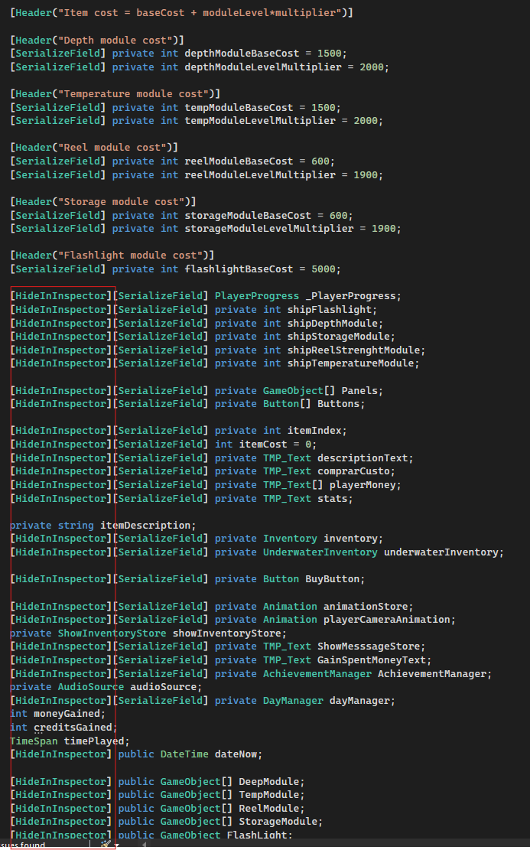

Figure 2.39: Shop manager script hiding unnecessary information in the Unity inspector by using the "HideInInspector" tag.

## Unity scripts

**MainMenuManager.cs –** Responsiblefor managing the UI in the menu and loading scenes.

**DialogController.cs** – Responsible for managing the dialog in the Tutorial scene.

**Fish.cs** – Holds the general information about the fish. Every fish has one Fish.cs script.

**FishController.cs** – Responsible for controlling fish spawns, activating fish in zones and setting maximum number of fish that spawn.

**FishSpawner.cs** – Responsible for spawning fish in a zone. Each zone has a FishSpawner.cs script.

**FishSpawnerBoundaries.cs** – Responsible for setting up a volume which fish can swim in. Must have eight child transforms to create a volume. Every volume has one FishSpawnerBoundaries.cs script

**FishWaypoints.cs** – Controls the movement of the fish in a specific volume. Every fish has one FishWaypoints.cs script.

**AchievementManager.cs –** Responsible for managing achievements. Updates achievements in case a player gets one, deactivates the achievement objects in case an objective was already achieved.

**AchievementObject.cs –** Holds the information related to an achievement object.

**AudioCuesManagerScript.cs –** Responsible for playing specific audio sounds to warn the player.

**CallDEECSupportScript.cs** – Responsible for manually respawning to base.

**CompassScript.cs –** Responsible for updating the compass object.

**ControlVolumes.cs –** Responsible for controlling the different types of visual volumes.

**CoRoutineAwaiterWrapper.cs –** Responsible for fixing an await method,

**DatabaseLoaderScript.cs –** Responsible for the communication of Unity to the database.

**DayManager.cs –** Responsible for terminating the day and starting a new one. It picks randomly the next day to day or night. Communicates to the DatabaseLoaderScript.cs to save data related to the ended day.

**HarpoonTrigger.cs –** Responsible for setting the harpoon speed, aiming, firing and reeling the fish.

**Inventory.cs –** Responsible for the player’s inventory. The space changes depending on the storage module level.

**LookAtPlayerCanvas.cs –** Allows the player to always see where the base is.

**MusicManagerScript.cs –** Responsible for playing music while the player is playing.

**PlayerDataScript.cs –** Instance created which holds all the information that was loaded from the database.

**PlayerHealth.cs –** Responsible for managing the player’s health and respawning.

**PlayerLookSimpleEDITOR.cs –** Responsible for the player’s movement in the tutorial scene.

**PlayerMovementWater.cs –** Responsible for the player movement in the game, checking the depth, changing the state from surface to underwater.

**PlayerProgress.cs –** Responsible for saving progress in the computer. This was substituted by saving in the database and is now obsolete.

**PlayerVisionController.cs –** Responsible for managing the colors of each biome and lerping them in a smooth way.

**ProxyHelper.cs –** Responsible for helping the Proxy.cs code not to fail. -Obsolete.

**ScreenSleepScript.cs –** Responsible for not letting the mobile sleep. – Obsolete since the game changed to be on PC.

**ShopButtonScript.cs –** Responsible for changing a button color when selected. – Obsolete since the game changed to not be VR.

**ShopManager.cs –** Responsible for managing the store. Updates to player modules, fish caught, coins gained, selecting modules are all done here.

**ShopProxyScript.cs –** Responsible for enabling the player to access shop through movements from the camera.

**StopStickPicker.cs –** Responsible for controlling the shop through VR. – Obsolete since game is no longer VR.

**ShowInventoryStore.cs –** Responsible for showing what the player caught in the present day in the shop.

**ShowPlayerMessageScript.cs –** Responsible for displaying messages to the player in game.

**StoreColliderScript.cs –** Responsible for capturing the player and bringing him to the engineering hub.

**StoreSubDecorator.cs –** Responsible for decorating the seamoth in the store, allowing the player to visually see how the different modules affect the seamoth.

**UnderwaterInventory.cs –** Responsible for storing and managing the inventory of the two men underwater.

**UnderWaterStoreFishScript.cs –** Responsible for managing and sending the fish and achievements caught to the two men.

**ZonesScript.cs –** Responsible for the creation and managing of the zones.

**Proxy.cs** – Responsible for decoding the data of the proxy program and mapping the movements to Unity.

## Gameplay

During development, the game was controlled using traditional key bindings for testing purposes. However, the final version is designed for motion-based gameplay, making it only possible to play through physical activity. To make this possible, a new program (python-based proxy program) had to be created to capture movement, map it and send it to Unity through socket communication. The next section will explain how it was developed.

# 

# 3

# Proxy program

**Contents**

3.1. Socket communication 55

3.2. OpenCV and MediaPipe 56

3.3. Calibration 57

3.4. Mapping movements in Proxy program 59

3.5. Fail safes 62

3.6. Receiving data in Unity from Proxy 63

## Socket communication

The connection between the proxy program and Unity is established through socket communication.

* Unity acts as the server, while the proxy program functions as the client.
* The proxy program attempts to connect to Unity using a local socket connection. If it fails, an exception is thrown.
* Once connected, the proxy continuously captures and sends data to Unity in JSON format.

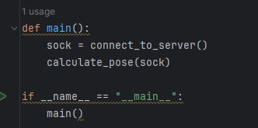

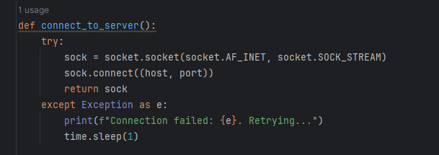

Figure 3.1: Start of the proxy program. First thing it tries to do is connecting to Unity.

* The send_data() method is responsible for transmitting data to Unity. If a transmission fails, an exception is triggered, closing the socket to allow for reconnection.

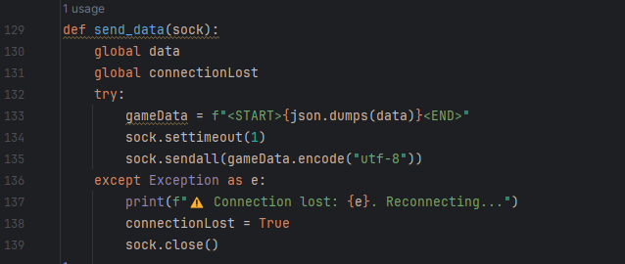

Figure 3.2: Method responsible for sending data to Unity. The gameData variable has the tags "<START>" and "<END> to prevent breaking in Unity."

## OpenCV and MediaPipe

The proxy program relies on OpenCV and MediaPipe for real-time body tracking.

* OpenCV (Open-Source Computer Vision) captures and processes video.
* MediaPipe applies machine learning to estimate joint positions based on a human body model.

How it works:

1. OpenCV captures video from the player’s camera.
2. Each frame is processed and prepared for MediaPipe.
3. MediaPipe extracts body landmarks using the mp_pose.Pose() method with detection and tracking values set to 0.5.
4. These landmarks are used to interpret the player's movements in real time.

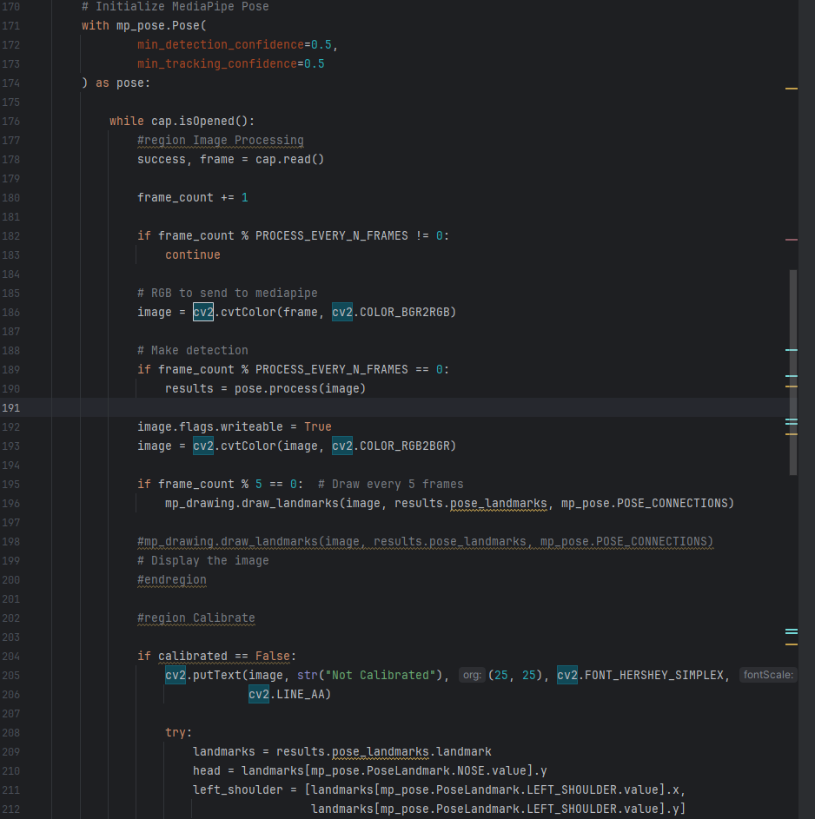

Figure 3.3: Code related to opencv and mediapipe.

## Calibration

Before gameplay begins, the proxy program performs a calibration check. It requires the player to assume a T-Pose, which serves as a baseline for tracking movements.

Why T-Pose?

* Establishes a reference point for movement tracking.
* Ensures players of different heights can play without issues.

T-Pose Detection:

* The player stands with arms extended horizontally.
* The angles between hip-shoulder-elbow joints must be approximately 90°.
* The angles between shoulder-elbow-wrist joints must be around 180°.
* Some tolerance is allowed to accommodate natural variation.

Helper Methods:

* Angle Calculation: Determines joint angles.
* Distance Calculation: Measures distance between key landmarks.

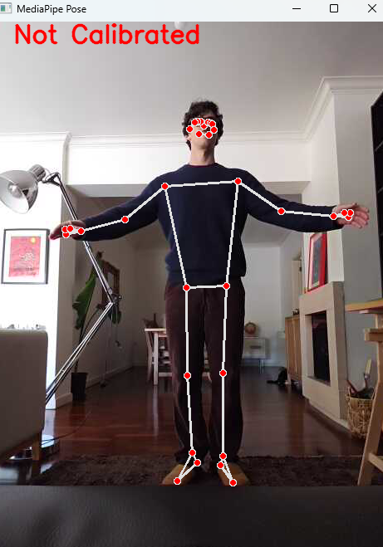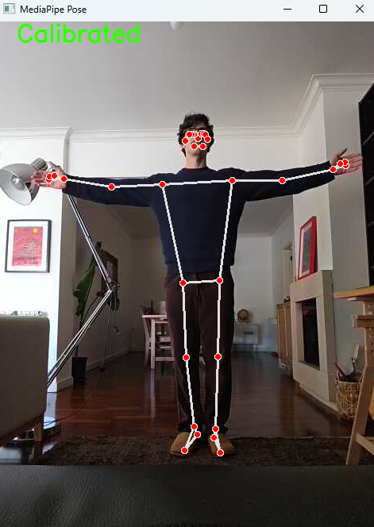

Figure 3.4: Calibration of the program. To ensure it can be used by multiple people of different heights, a calibration is needed where the person playing will do a T-pose.

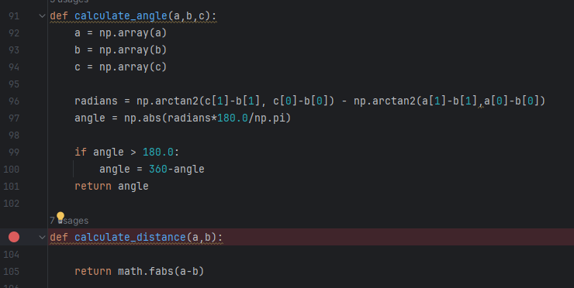

Figure 3.5: Two methods returning the angle of three joints and the distance of two joints.

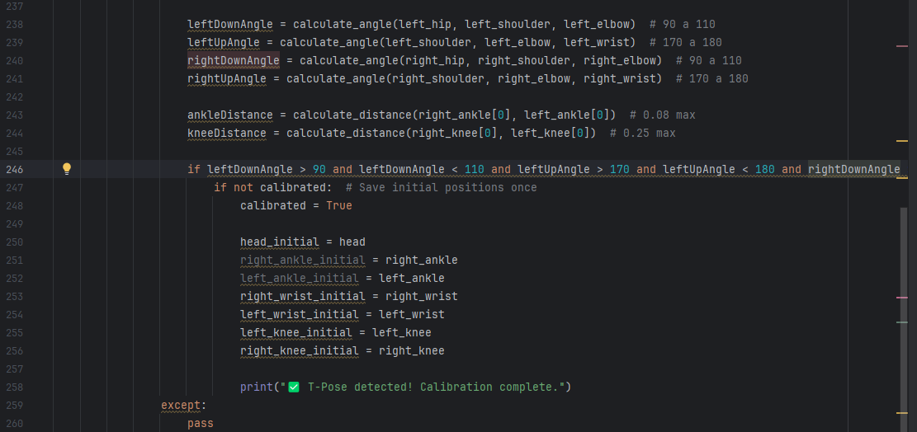

Figure 3.6: Calculation of the T-Pose.

## Mapping movements in Proxy program

To play the game it is needed to create movements which will dictate inputs to Unity. The data that Unity needs to play the game is the following:

Horizontal value responsible for the movement in the X axis.

Horizontal value responsible for aiming in the X axis.

Vertical value responsible for the movement in the Y axis.

Vertical value responsible for aiming in the Y axis.

Fire command to fire the suction pad to catch fish.

Harpoon mode to change from firing mode to movement mode.

Is reeling boolean which is true when doing exercise, reeling the fish.

After several tries of coming up with ways to play the game, it was decided that for the vertical movement, the joints of the knees were used. These joints need to be in a higher position than their initial T-Pose position to be able to move in the Y axis – meaning that the lifting of the knees makes the player move forward in the game.

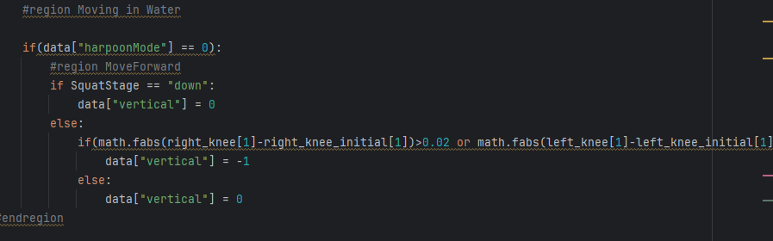

Figure 3.7: Code responsible for moving forward by checking knee joint positions.

The fire mode was decided to change state when the player lifts the left hand higher than the head. If the player is in fire mode and lifts the left hand, the state goes to movement mode and vice versa.

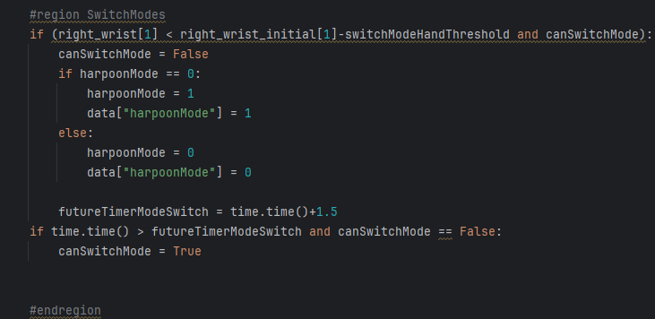

Figure 3.8: Code responsible for changing the fire state. The two states are fire mode and movement mode.

Firing the suction pad only works when the player is on the fire state and is done by extending the left hand sideways.

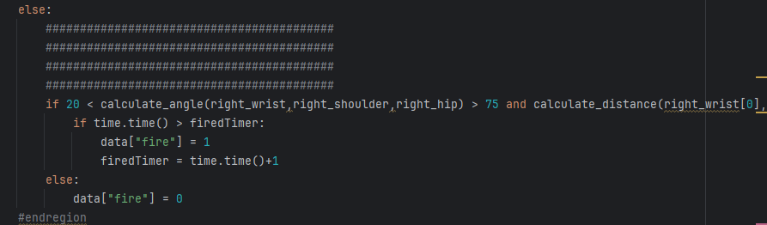

Figure 3.9: Code responsible for firing the suction pad.

After firing, if the suction pad hits a fish, the player needs to do squats to reel in the fish. This is done by checking the head position related to the initial head position saved in the calibration process. The player has one and a half seconds to start doing a squat. If the head is lower than the reference, then the player has an additional one and a half seconds to complete the squat, changing the “IsReeling” variable value to one. If the player fails to complete the squat, then the “IsReeling" variable changes to zero.

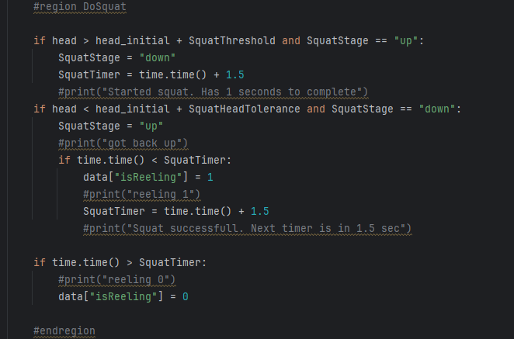

Figure 3.10: Code responsible for performing a squat and changing the variable IsReeling to 1.

Controlling the direction of the camera is done by mapping the right wrist joint position. When the joint passes a certain resting threshold, the camera will either look left, right, up or down according to the wrist joint position.

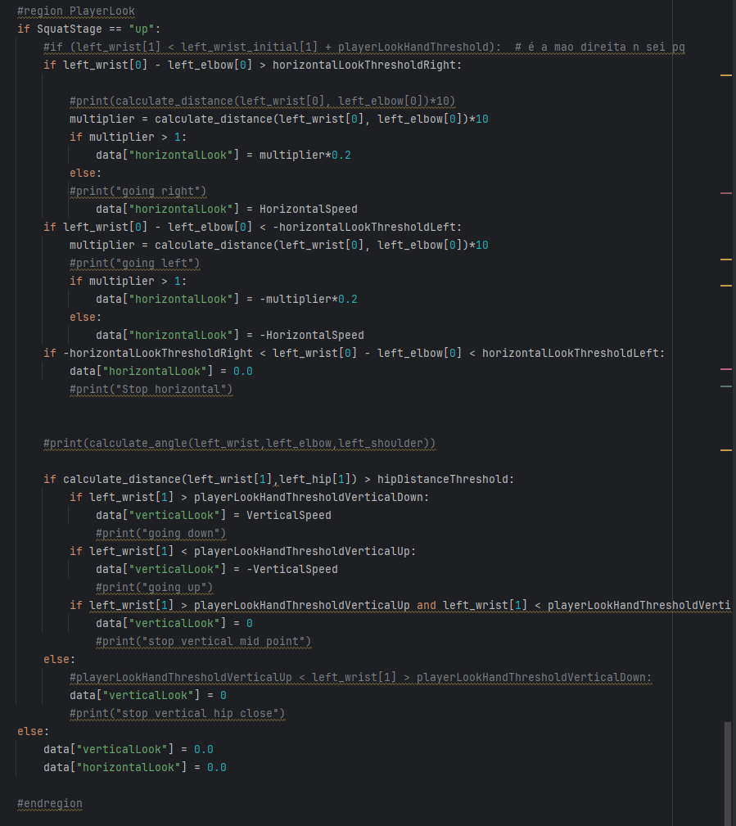

Figure 3.11: Code responsible for controlling the direction of the camera.

Recalibration is possible by lifting the left and right wrist joints closely together to a position higher than the initial head position. This ensures that a new calibration can take place so another player can play the game.



Figure 3.12: Code responsible for activating a new calibration process.

Reeling fish is done while doing exercises. These exercises need to be mapped and alter the variable IsReeling in Unity. The Unity script responsible for bringing the fish closer is constantly checking the IsReeling value. If IsReeling value is true, then the fish will steadily come closer to the player. If the value is false, it will stop reeling. Since fish have a break free timer, the player needs to constantly try to have this value on true.

## Fail safes

To ensure stable gameplay, multiple fail-safe measures have been implemented on both the client side (proxy program) and server side (Unity).

Why are fail-safes necessary?

* When Unity changes scenes (e.g., transitioning between players), the socket connection can become unresponsive.
* Without fail-safes, this would require a full game restart.

Solution:

* The proxy continuously monitors the connection.
* If a connection issue is detected, a new socket is automatically created, allowing for seamless reconnection.

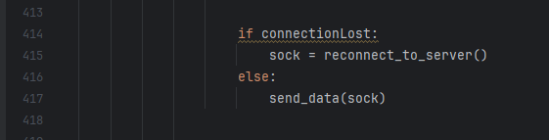

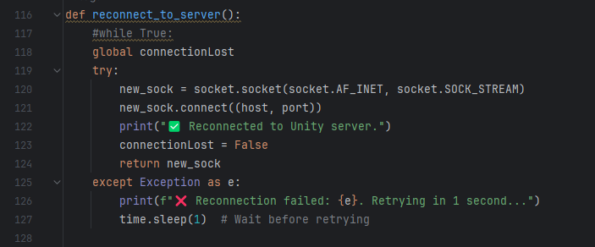

Figure 3.13: Constant check in while loop for connection in the first image. When connection is lost, the reconnect_to_server() method is called which creates a new connection.

## Receiving data in Unity from Proxy

Unity (server) receives the information coming from the proxy program in JSON format. This data will be decoded and mapped to the necessary variables to play the game.

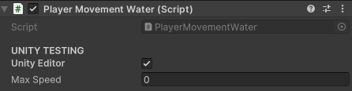

Figure 3.14: Most of testing was made with the "UNITY TESTING" ticked. A controller was created to play in the computer to test everything nonrelated to movement.

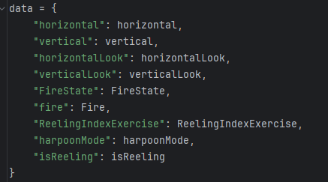

Figure 3.15: Print of the data variable that we send to Unity in the python program.

In Unity, we receive this data and decode it to fit our needs. We have the same data that is received from the client.

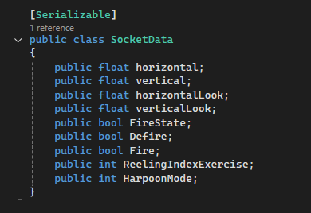

Figure 3.16: Class needed for decoding the data coming from python program.d

This data is needed to play the game, and it is this data that we receive from the client by json. The mapping is done using the following method:

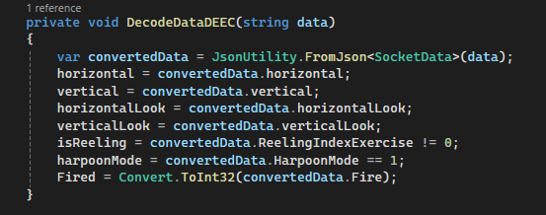

Figure 3.17: Code responsible for receiving the data from json and decoding it.

However, the data was being repeated and sometimes split. To fix this issue a method was created:

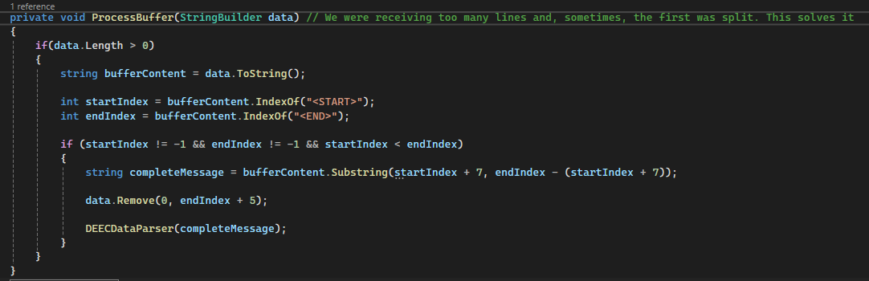

Figure 3.18: Overriding the problem of repeated data.

# 4

# Frontend development

**Contents**

4.1. Web page 67

4.2. Port configuration 68

4.3. Validations 68

4.4. API connection 69

## Web page

The game’s web interface is built using Blazor, allowing students to register with their student IDs. To facilitate users’ registration, a QR code was generated that redirects them to the registration website.



Figure 4.1: QR code that remits to "misteriosaquaticos.pt" where players can register. The QR code was made by using a free QR code generator.

The frontend is hosted on a Docker container with an SSL-secured domain (misteriosaquaticos.pt). The setup ensures:

* Secure HTTPS connections.
* Compatibility with both desktop and mobile devices.

The code responsible for managing if the user is accessing through mobile or desktop is done in the app.css file. The default orientation is landscape, however, if portrait orientation is detected, it will render it in a different way.

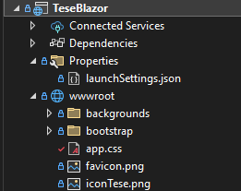

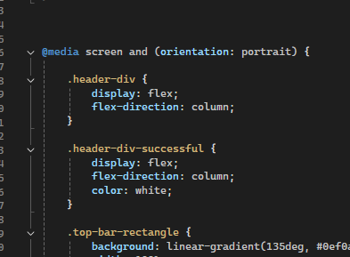

Figure 4.2: These two images show where the in the code it applies the correct orientation.



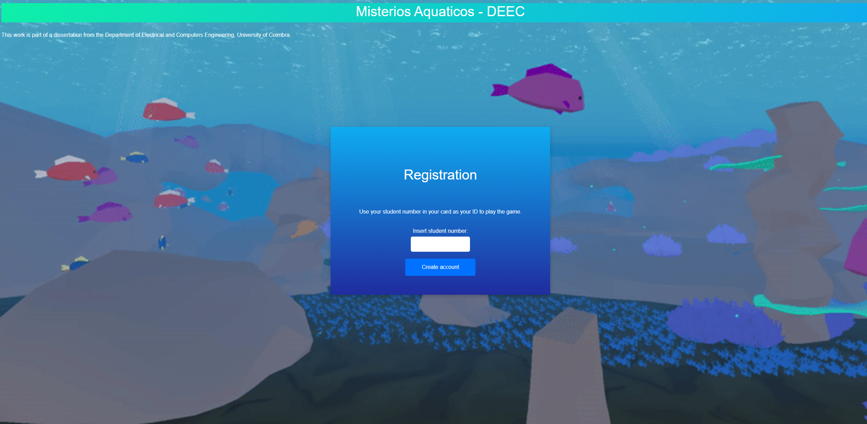

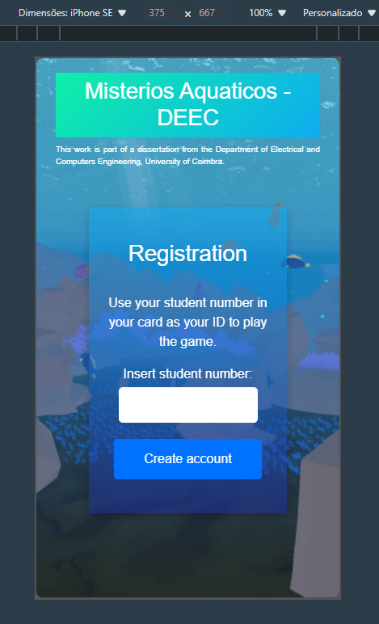

Figure 4.3: Mobile and computer versions of the website.

## Port configuration

The web infrastructure uses multiple ports for different functionalities:

* Port 8080 → Hosts the Blazor frontend (misteriosaquaticos.pt).
* Port 8081 → Handles API requests (/api).

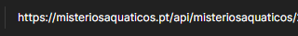

Figure 4.4: Endpoint related to API.

## Validations

To ensure a correct registration process, some validations are in place:

1. Student ID format validation:
   * Must be exactly 10 digits.
   * Only numeric values are allowed.
2. Duplicate ID check:
   * Prevents multiple registrations with the same ID.
   * This validation is handled at the API level.

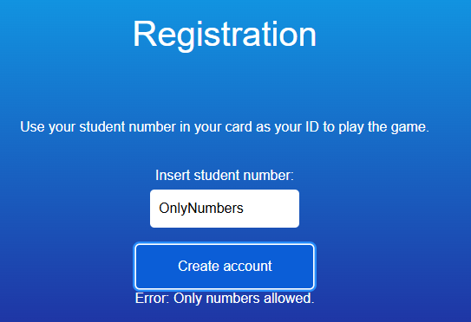

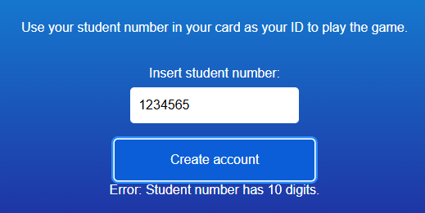

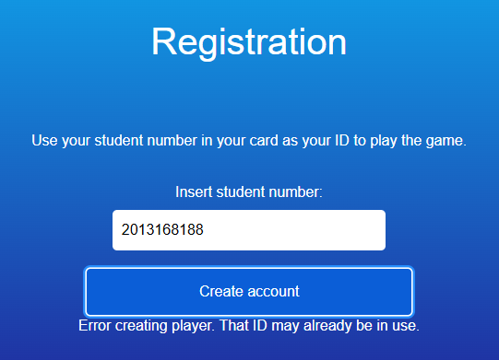

Figure 4.5: These three images show the validations that exist in the frontend. We will only accept numbers with ten digits and IDs that are not already in use.

## API connection

Players register by calling an API endpoint, which validates their ID and ensures it hasn’t already been registered. As mentioned earlier, the API runs on port 8081 and is accessible via /api/. This API is built using .NET 8.

# 5

# Backend API development

**Contents**

5.1. SOLID principles 74

5.2. Architecture & good practices 74

5.3. REST APIs 74

5.4. Testing the API 74

5.5. Validations 75

5.6. Endpoints 75

5.7. Swagger 77

5.8. Postman 77

5.9. Port configuration for API 78

5.10. Client Resilience 78

5.11. Authentication 79

5.12. Database connection 79

5.13. Github 79

5.14. Database 80

## SOLID principles

SOLID principles are a set of principles on which programmers try to implement it to develop cleaner and more readable code. Each letter in SOLID means one specific tactic.

**Single responsibility** – A class should only have one reason to change and be responsible for a specific subject. This keeps the code modular and easier to maintain.

**Open close principle** – A class should be open for extension but closed for modification. This means that new features can be added without modifying existing code, reducing the number of bugs.

**Liskov substitution** – Objects of a subclass should be replaceable by their superclass without altering behaviour. This ensures reliable inheritance and avoids unexpected behaviours.

**Interface segregation** - Clients should not be forced to depend on interfaces they do not use. This prevents unnecessary dependencies.

**Dependency inversion** – High-level modules should not depend on low-level modules. They both should depend on abstractions. This improves flexibility, improves testing and reduces the amount of code needed.

By applying SOLID principles, the code becomes more scalable, easier to test and more adaptable to future changes.

## Architecture & good practices

When creating a project with a significant size, it is advised to have architecture in mind. This will allow the project to be scalable and easier to work with. Separating business logic from requests is advised, as well as having the code tests.

## REST APIs

REST APIs is a way for different software systems to communicate over the internet using standard HTTP methods. These methods are:

GET – Retrieve data

POST – Create new data

PUT – Update data

DELETE – Remove data

Reordering the methods description gives us the very well-known word CRUD. REST APIs are widely used because they are scalable and easy to integrate.

## Testing the API

Testing is a crucial part of software development. The API was tested using Unit and Integration tests to verify its functionality.

* Unit Tests:
  + Focus on individual components.
  + Ensure changes do not break existing logic.
  + Typically small and targeted.
* Integration Tests:
  + Cover broader functionality.
  + Essential for verifying database-related operations.

While E2E (End-to-End) and Contract Testing exist, they were not included in this project.

## Validations

Validations act as a safeguard against improper inputs and ensure data integrity. The API includes:

-Check if user is registered.

-Ensure the credits value is higher than 0 when updating credits

These checks prevent errors and ensure users receive meaningful feedback.

## Endpoints

To ensure seamless interaction between applications, multiple API endpoints have been implemented to handle various requests.

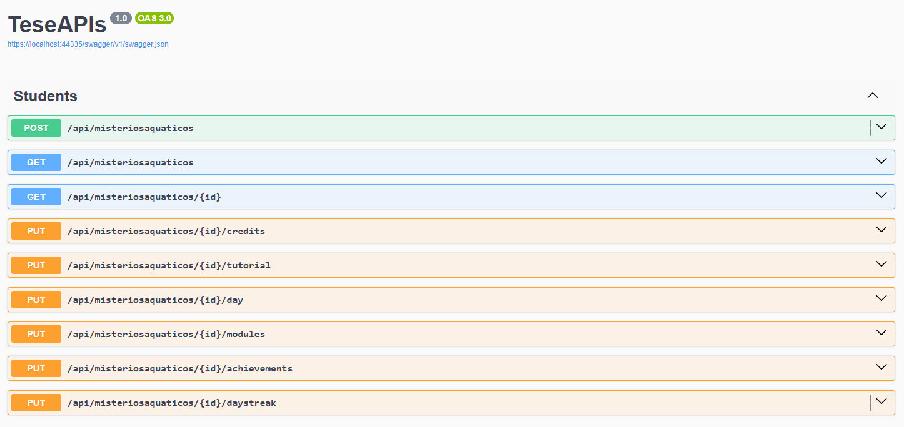

Figure 5.1: Using swagger in the development is useful to test the API endpoints.

POST api/misteriosaquaticos

This endpoint is called when users are registering. It has a validation that checks if a user with the ID that was sent already exists. Unity and SuperUser application call this endpoint.

GET api/misteriosaquaticos

This endpoint returns all the players and their data that exist in the database. SuperUser application call this endpoint.

GET api/misteriosaquaticos/{id}

This endpoint returns one player with the ID sent and his data. SuperUser application and Unity call this endpoint.

PUT api/misteriosaquaticos/{id}/credits

This endpoint updates the credits of the player with ID sent. The credit value is sent in the body as json. The application SuperUser calls this endpoint.

PUT api/misteriosaquaticos/{id}/tutorial

This endpoint is called from Unity and updates the tutorial field of the player with the ID that was passed. This tutorial value is set to one and saved in the database, meaning that this player will not need to see the tutorial again.

PUT api/misteriosaquaticos/{id}/day

This endpoint is called from Unity and updates the coins, fish caught, time played, days and credits.

PUT api/misteriosaquaticos/{id}/modules

This endpoint is called from Unity whenever the player buys a new module.

PUT api/misteriosaquaticos/{id}/achievements

This endpoint is called from Unity when the player conquers an achievement.

PUT api/misteriosaquaticos/{id}/daystreak

This endpoint is called from Unity whenever the player enters the game. It calculates the last login and, if fit, it updates the day streak value. This value will affect the number of credits received.

Day streak 0 – x1.0 multiplier.

Day streak 1 – x1.25 multiplier.

Day streak 2 – x1.5 multiplier.

Day streak 3 – x2.0 multiplier.

These values can be adjusted.

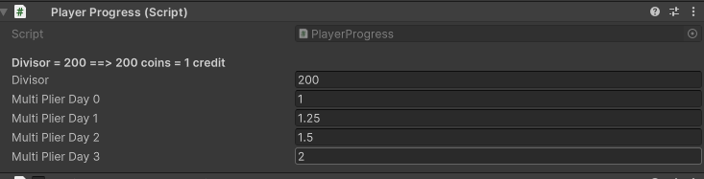

Figure 5.2: Progress of players. It is possible to choose the conversion of coins to credit and the day streak multiplier.

There are times when we need to obtain information, so responses were created.

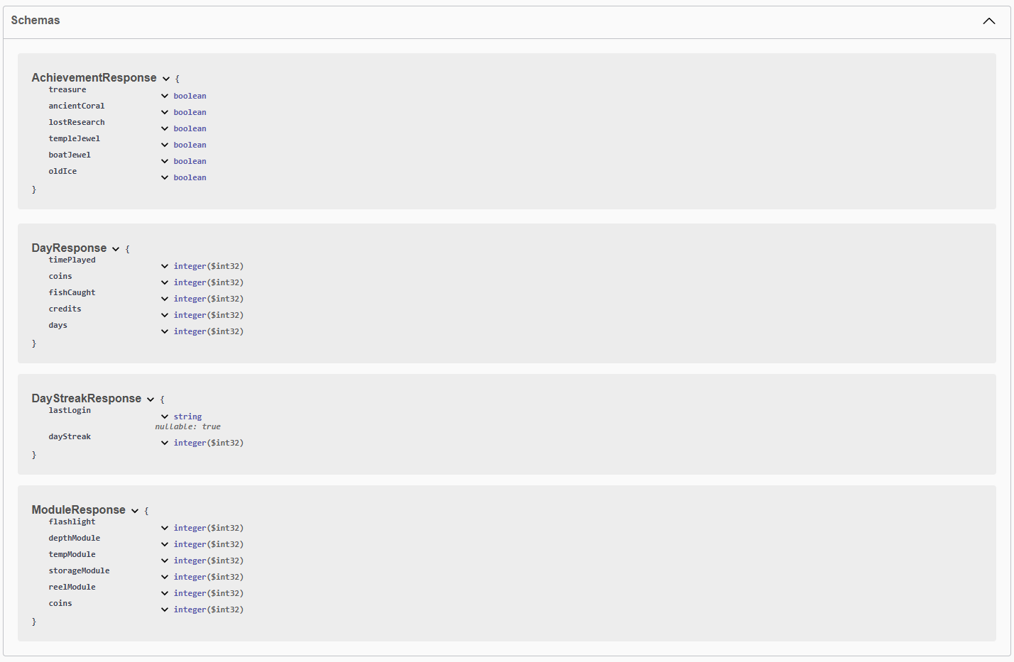

Figure 5.3: Responses of the API when calling the endpoints.

## Swagger

Swagger is primarily used for API documentation and testing during the development. It is generated from the API code and allows developers to test endpoints directly from the browser. Swagger is particularly useful while developing in a local environment and was extensively used in the development of this dissertation.

## Postman

Postman allows users to send requests, add authentication headers, test APIs deployed in Docker or on remote servers. After the API was deployed in Docker, the tool of testing switched from Swagger to Postman. Postman was extensively used in the development of this dissertation.

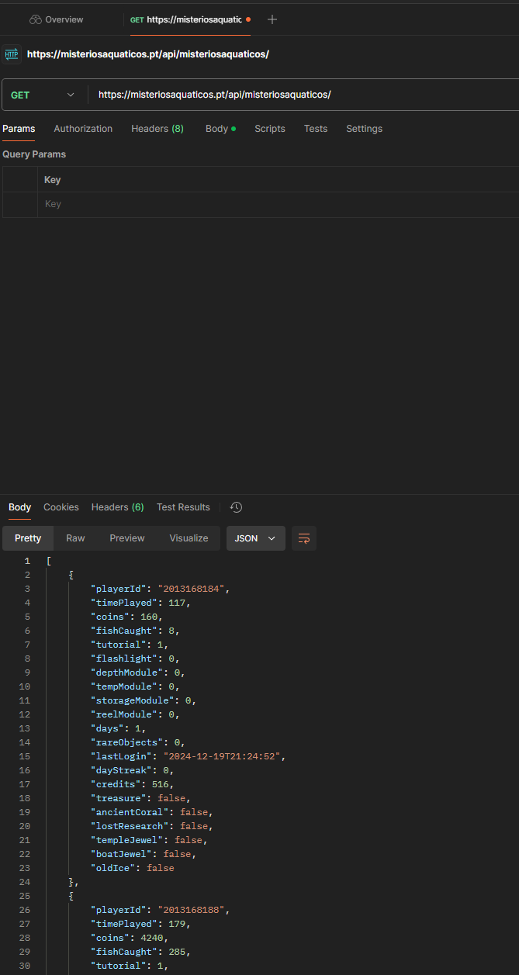

Figure 5.4: Testing the API endpoints in Postman.

## Port configuration for API

The API is configured to use port 8081, which is mapped to /api/ for easy access.

## Client Resilience

To improve reliability, the API uses Microsoft’s HTTP Resilience package. This ensures that requests automatically retry before failing, preventing unnecessary disruptions. To implement client resilience in .NET, we do the following in the program.cs class:

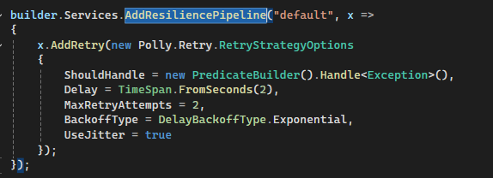

Figure 5.5: Implementation of client resilience in the program.cs.

This means that for our default resilience pipeline, we will use the options described above. And in our API controller we need to add the following code, so we use the pipeline instead of the normal API call. This mechanism enhancesfaulttolerance by retrying failed requests dynamically.



Figure 5.6: Implementation of client resilience in the controller.

## Authentication

Authentication ensures that only authorized users can access the API. Without authentication, anyone could manipulate data. Proper authentication mechanisms were implemented to secure sensitive endpoints. This, however, is not implemented.

## Database connection

Since Sqlite is being used as the database, the connection is done by changing the DB_PATH to the sqlite .db file. This sqlite file is stored in the Docker container.

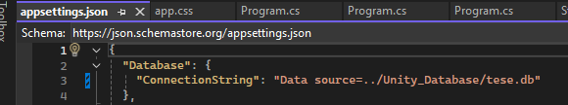

Figure 5.7: Database connection string specifies to a file - tese.db.

## Github

Version control is essential for tracking changes. GitHub was used extensively throughout this project for:

* Managing code changes.
* Rolling back to previous versions if necessary.
* Collaborating efficiently in a structured workflow.

## Database

### Why SQLite?

SQLite was chosen because:

* It is lightweight and fast.
* It does not require a separate database instance.
* It operates as a file-based database, making it easy to manage.
* Given the simple nature of the stored data, SQLite is an optimal choice.

### Tables schema

There are two tables in the database, MisteriosAquaticos and Achievements. MisteriosAquaticos table is responsible for keeping most of the data, while the Achievements table is responsible for keeping track of the achievements.

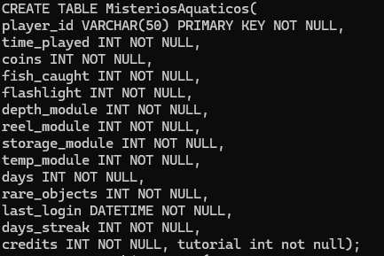

Figure 5.8: MisteriosAquaticos table schema.

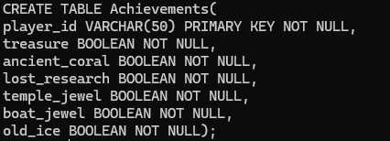

Figure 5.9: Achievements table schema.

# 

# 6

# Deployment

**Contents**

6.1. Server 79

6.2. Command line 79

6.3. WinSCP 79

6.4. Portainer 79

6.5. Domain misteriosaquaticos.pt 80

6.6. Docker 81

6.7. Faster deployment 82

6.8. Nginx SSL certificate 84

6.8.2. Adding the SSL certificate 85

## Server

To run the applications continuously and store player data, a Linux-based server was rented.

* Host provider: Hetzner.
* Software installed: Docker for container management.
* Storage: SQLite database stored within the server environment.

## Command line

Server management is performed via SSH:

“ssh user@serverIp”

From here, Linux commands are used to create directories, install software, and manage the system.

## WinSCP

While all tasks can be done via command line, WinSCP provides a graphical interface for file transfers and server management.

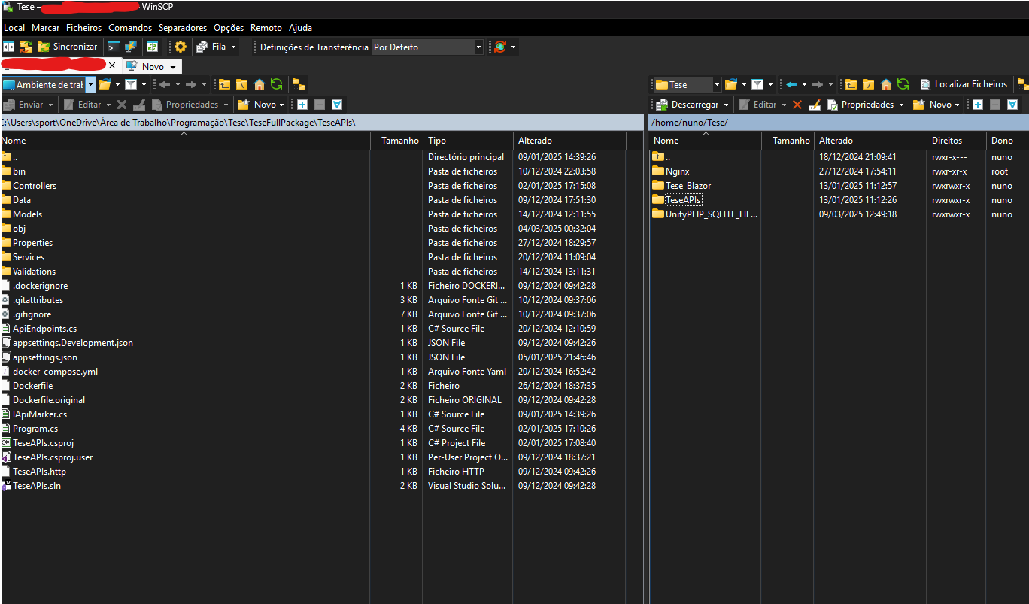

Figure 6.1: Using WinSCP to manage the server data.

## Portainer

Portainer is a web-based container that simplifies the management of Docker enrinoments. It provides a graphical interface for managing docker containers, images, networks and volumes without using the command line.

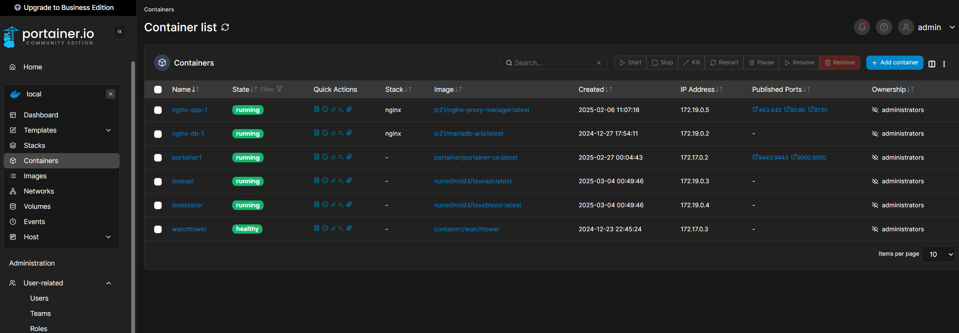

Figure 6.2: Image shows how Portainer helps to visualize docker related subjects in an easier way.

Portainer is entirely optional, and the normal command line can be used instead.

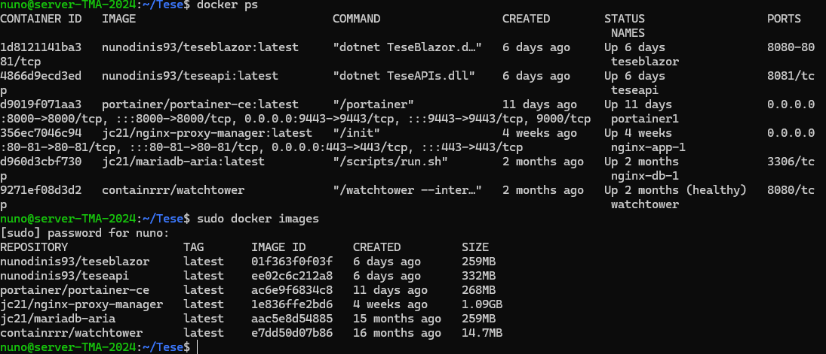

Figure 6.3: Alternative to using Portainer is checking docker trough command line.

## Domain misteriosaquaticos.pt

To make the project more professional and secure, a custom domain was purchased from Dominios.pt.



Figure 6.4: Client area of Dominios.pt.

### Mapping server IP to domain

The domain misteriosaquaticos.pt is mapped to the server’s IP in the domain configuration page.

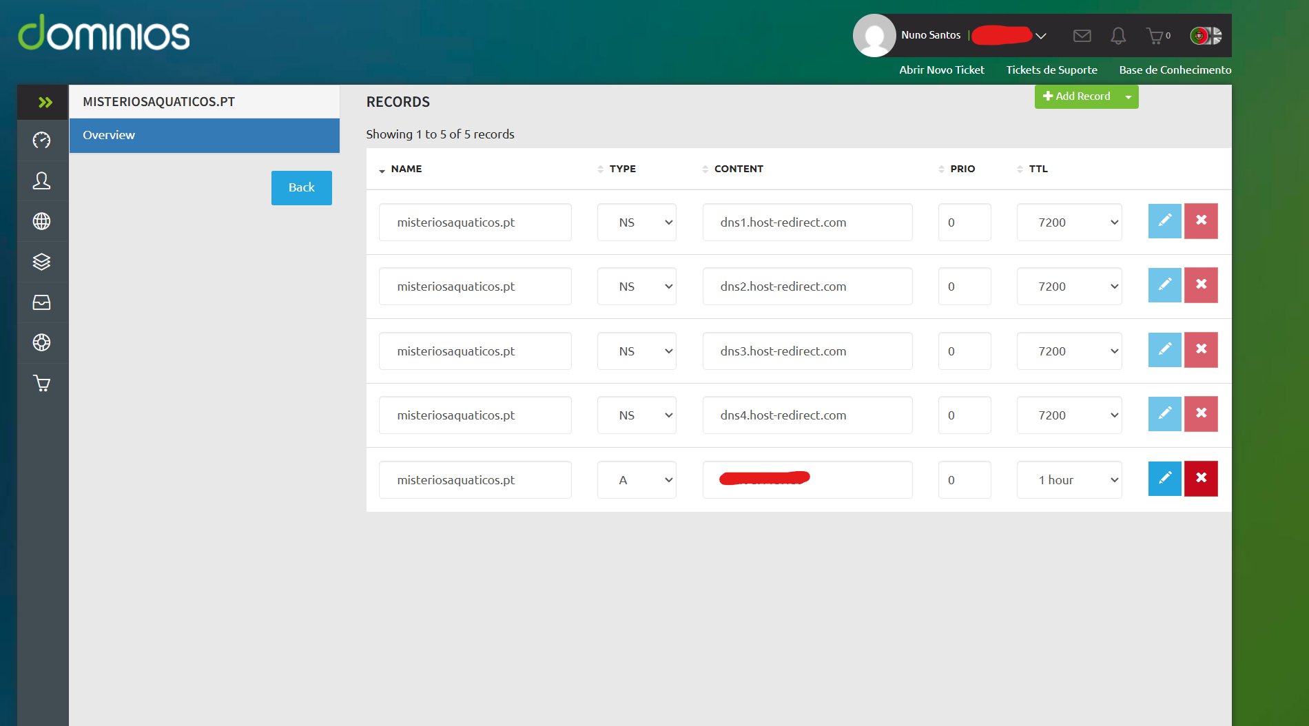

Figure 6.5: Setting up the domain to the server IP.

### Why use a domain?

Using a domain gives several advantages:

* Hides the server IP to prevent direct access.
* Enhances security by reducing exposure to attacks.
* Looks more professional instead of using a raw IP address.

## Docker

### Why use Docker?

Docker enables the application to run continuously by packaging it into containerized images. This ensures:

º Easy deployment.

º Consistent environment across different machines.

º Fast recovery in case of failure.

### Setup in server

The server was initially an empty Linux OS, and Docker was installed to handle containerized applications.

### Docker images

Docker images act as blueprints that define the software, libraries, and configurations required to run an application. They are built using Dockerfiles, which specify the steps to assemble the image. To create an image for a project, the necessary .dll files (or other dependencies) are included, often defined in a docker-compose.yml file.

When the images are built, it is possible to create containers from them to run the application. The command:



is used to build the images and start the containers in detached mode. The detached flag is useful to not lock the terminal.

The docker-compose.yml file defines which services need to be built, their dependencies, and how they should run inside containers.

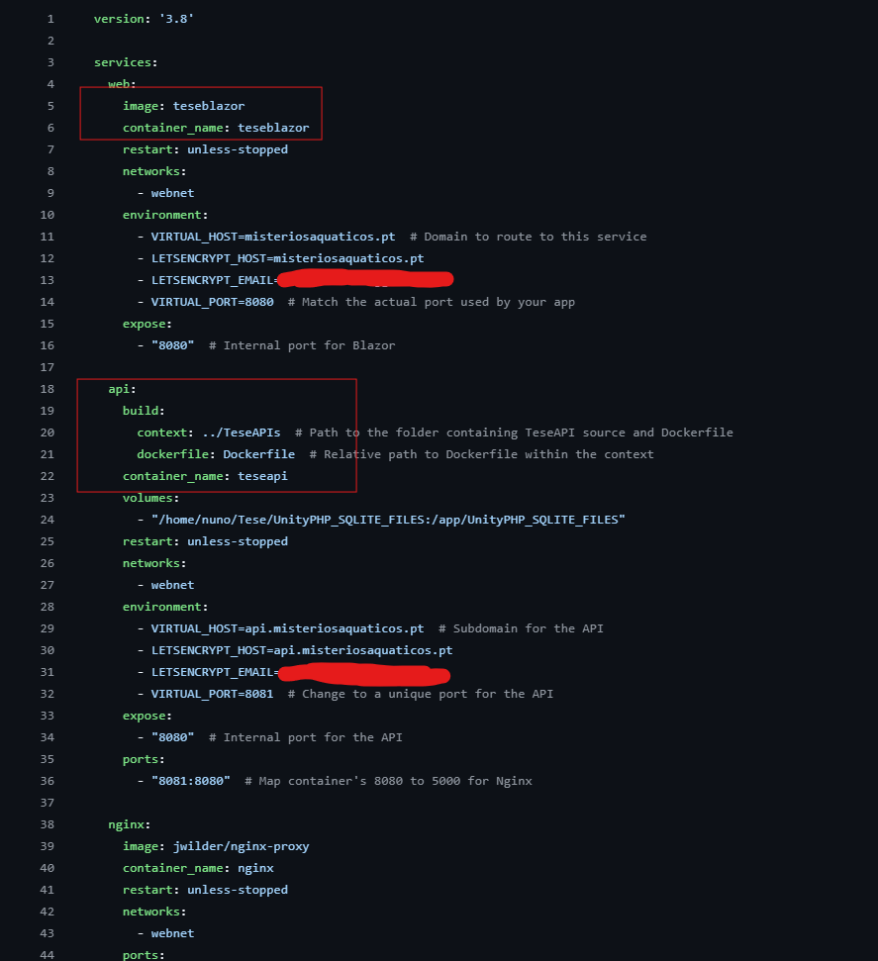

Figure 6.6: Docker compose file holds the blueprint for teseblazor and teseapi projects.

To create docker containers based on the images, the following command is run for each image. The following command creates a container teseblazor:



### Docker container

Docker containers are built from images, and they allow us to have our applications running. They are lightweight and portable environments that package applications and their dependencies, ensuring they run consistently across different systems.

## Faster deployment

Deploying the applications, creating docker images, creating containers is a repetitive task which takes some time. Luckily there are ways to automate these procedures.

### GitActions

To automate deployment, GitHub Actions were configured.

* On each commit, the system builds and pushes updates to DockerHub.
* A YAML configuration file (main.yml) handles this process.

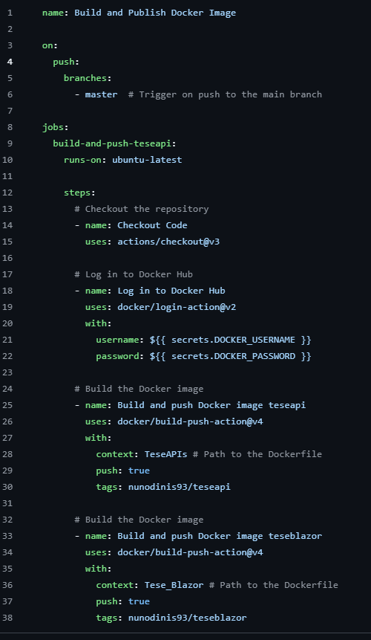

Figure 6.7: Script that detects a new commit, builds it and pushes it to docker hub.

### Docker hub

Docker Hub simplifies development with a powerful container registry for storing, managing, and sharing Docker images[X]. It is a container registry for developers to find, use and share their container images. In this dissertation, a Docker Hub account [7.8] was created with two public repositories containing the images of both the API and frontend. By using Watchtower, a container running on the server that periodically checks for updates in the Docker Hub repository, it is possible to automate deployment. Whenever a new image is pushed to the docker hub repository, Watchtower detects the update and automatically pulls and redeploys the latest version of the container, ensuring that the system remains up to date with minimal manual intervention.

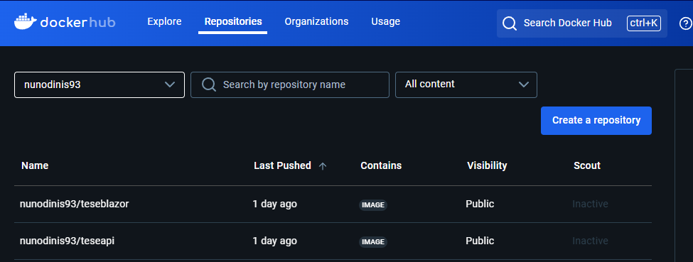

Figure 6.8: Dockerhub detects new images and builds new images.

### Watchtower

Watchtower constantly monitors for new docker images [7.9] in the docker hub and, if an update is detected, it deletes the old containers and creates new ones. This ensures that the latest version is always deployed without manual intervention.

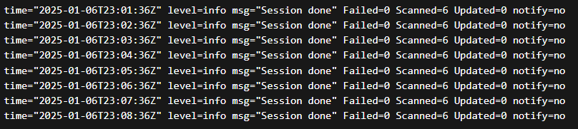

Figure 6.9: Watchtower installed in server that constantly checks for new docker images. If one is detected, a new image will be built in the server

## Nginx SSL certificate

### Why need SSL certificate?

SSL certificates enable HTTPS, making the website secure and professional.  
Without SSL, users would receive a security warning when visiting the site.

To implement an SSL certificate, a cert was created in nginx and added to the misteriosaquaticos.pt domain.

### Adding the SSL certificate

The SSL certificate was created using nginx proxy manager. By accessing the published port 81:81, it is possible to access the SSL certificates tab and add a certificate provided by Let’s Encrypt, as shown the figure [7.10].

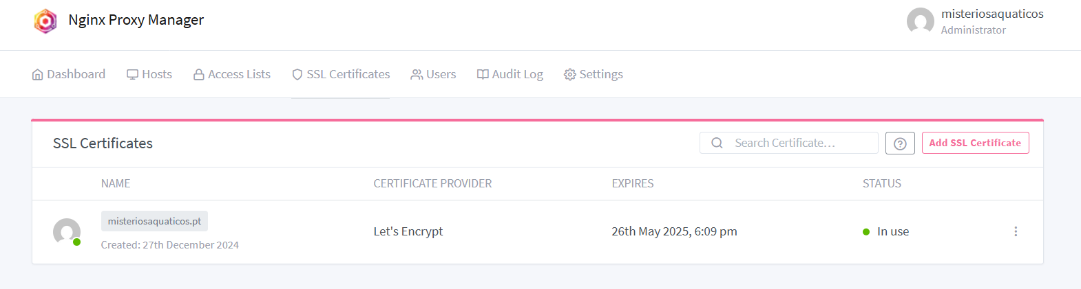

Figure 6.10: Nginx Proxy Manager location where it is possible to add SSL certificates to the domains.

# 

# 7

# Super user APP

**Contents**

7.1. MAUI app context 90

7.2. Receiving students 92

7.3. Updating credits 93

## MAUI app context

Since no direct connection exists between the university’s database and this project, a Super User (SU) app was created to manually manage player credits and rewards.

How It Works

* Displays a list of registered students.
* Allows searching for a specific student.
* Enables updating credits for a student.
* Updates are applied through API calls.

Credit Management

* The app retrieves all students from the API.
* Users can increase or decrease credits via the "Update Credits" button.

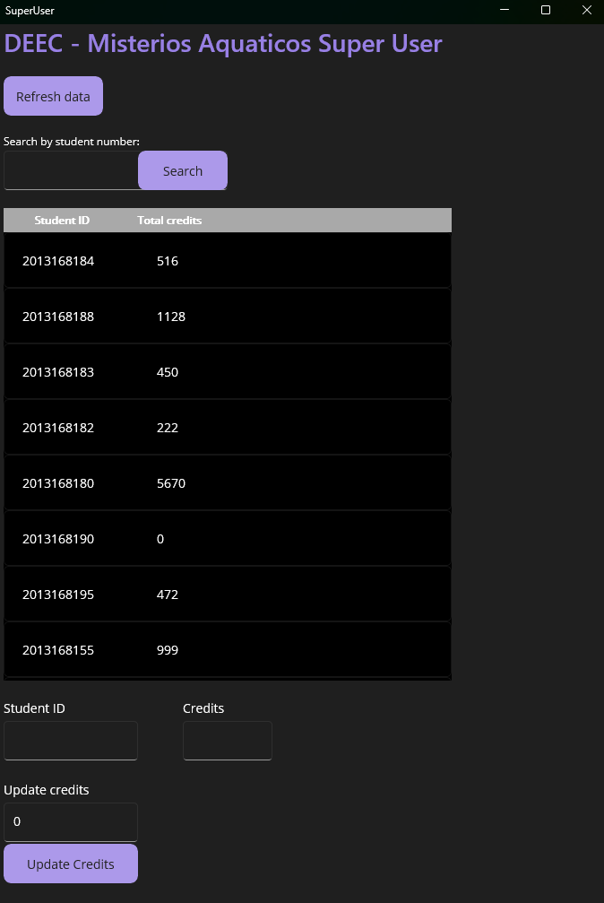

Figure 7.1: Super user app UI.

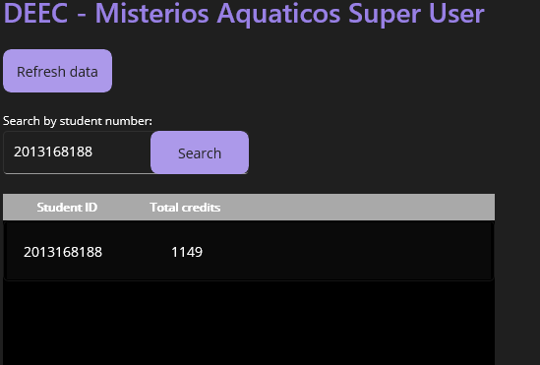

Figure 7.2: Searching for a specific student number. When searching for students, a small loading circle will appear letting the user know it is searching for students.

## Receiving students

Receiving all students is done by calling a GET endpoint in the API. These students will then be added to a list where it will be displayed in the super user app.

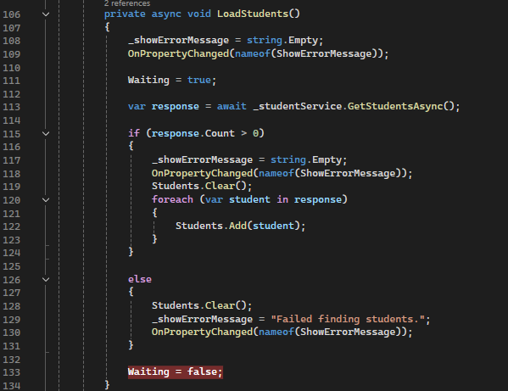

Figure 7.3: Code to get all students and add them to the list.

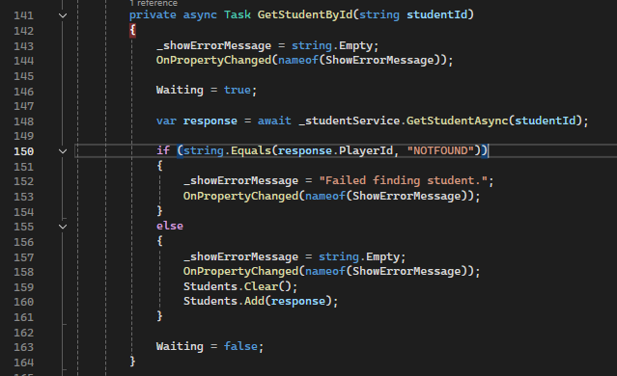

Figure 7.4: Code to search for a specific student.

## Updating credits

After selecting a specific student, we can add or subtract credits to that student. This is done by calling the UPDATE endpoint of the API. After clicking the button “Update Credits” the student with the ID specified will have the credits altered.

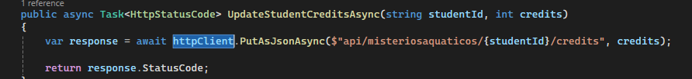

Figure 7.5: Code to update credits for a specific student.

# 

# 8

# How it **all** connects

**Contents**

8.1. Deployment pipeline 91

8.2. Unity connection to the API 91

8.3. Super User APP connection to the API 91

8.4. Frontend connection to the API 91

## Deployment pipeline

* 1. Code is updated and pushed to GitHub.
  2. GitHub Actions detects the change, builds the project, and sends it to DockerHub.
  3. DockerHub stores the new image.
  4. Watchtower detects the update and restarts the application on the server.
  5. The application runs with the latest version.

## Unity connection to the API

Unity provides built-in methods to make API calls, allowing the game to retrieve and store player progress efficiently. From Unity’s perspective, it is only needed to know which endpoints to call.

## Super User APP connection to the API

The API connection is done in the program.cs file.

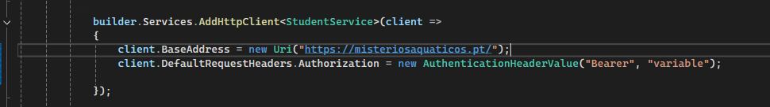

Figure 8.1: Connection of the SU app to the API in the program.cs

## Frontend connection to the API

Connection to the API from the frontend differs from the connections of Unity and the Super User app. Unlike Unity and the Super User app, the frontend is inside the docker container along with the API. For this reason, the connection is done from the inside of the container.

# 9

# Building the package

**Contents**

9.1. Building the package 93

## 9.1. Building the package

To run the game, both the Unity application and Python proxy program must be installed in the computer. A setup package was created to automate installation of all dependencies. This package is composed of:

* Unity game created by using the build settings in Unity.
* Python proxy program created by using the commands:

pip install -r requirements.txt

pyinstaller –onefile –name=proxy_program ControllerCV.py

* Creation of the executable file using Inno setup to compile a script which generates the executable file.

[Setup]

AppName=MisteriosAquaticos

AppVersion=1.0

DefaultDirName={pf}\MisteriosAquaticos

DefaultGroupName=MisteriosAquaticos

OutputDir=.

OutputBaseFilename=MisteriosAquaticosInstaller

Compression=lzma

SolidCompression=yes

[Files]

Source: "GameBuild\*"; DestDir: "{app}\Game"; Flags: recursesubdirs

Source: "dist\proxy.exe"; DestDir: "{app}\Proxy"

[Icons]

Name: "{group}\MisteriosAquaticos"; Filename: "{app}\Game\MisteriosAquaticos.exe"

Name: "{group}\Proxy"; Filename: "{app}\Proxy\proxy.exe"

[Run]

Filename: "{app}\Proxy\proxy.exe"; Description: "Start Proxy"; Flags: nowait postinstall

Figure 9.1: Script used to generate the executable file. This script is compiled in Inno setup.

# 

# 10

# Conclusion

**Contents**

10.1. Rewards 95

10.2. Results of gameplay 95

10.3. Future work 95

With all components—the game, proxy, API, frontend, and Super User app—a fully functional ecosystem is now in place.

This project successfully combines exercise and gaming, encouraging students to be active while earning rewards.

Beyond entertainment, this project demonstrates how technology can promote a healthier lifestyle and serve as a stepping stone for future development.

## Rewards

Rewards are currently manually managed via the SU app. In the future, this process could be integrated with the university’s system. Some examples of rewards are pencils, pens or even meal tickets for the cafeteria.

## Results of gameplay

Testing the game demonstrated its effectiveness as an exercise tool. During gameplay, the heart rate reached 120 bpm during active moments, and approximately eighty to ninety calories were burned in just 10 minutes. Measurements were taken using a Samsung Galaxy S7 watch.

## Future work

Although this project is fully functional and ready for use, there is still room for improvement. Potential enhancements include:

* Implementing API authentication
* Creating customized events to boost user retention
* Integrating with academic services to manage the database and enable credit recognition in university applications
* Replacing the Super User APP with automated credit spending options within the university application, such as vending machines for healthy snacks that accept credits

# 11

# Repository

**Contents**

11.1. Repository 97

## 11.1. Repository

[**NunoDinisSantos/Tese-DEEC**](https://github.com/NunoDinisSantos/Tese-DEEC)